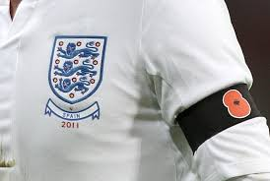

**Poppy ban lifted!**

Last year FIFA fined England, Wales, Scotland and northern Ireland for wearing poppies but now they are being told to lift the ban on them. The ban is expected to be lifted between the 6th and 14th of November.

By Wilf Hewitt-Grainger

7th Edition – 25th September 2017

By children, for children.

DILTON TIMES



**What’s happened in North Korea?**

It’s happened many times before because the government in Pyongyang, the capital of north Korea, has been testing nuclear weapons.

Reports in the USA say North Korea has now made nuclear missiles which have enough distance to reach the states.

By Oscar Froggatt and Freya Hodgkinson-Rowe

**Should tackling in Rugby be banned in schools?**

I’m sure you all know that rugby is a contact sport. And I’m sure you all know that it is the second favourite sport of the nation. But some headmasters and professors are pleading the UK’s chief medical officers (CMO) to protect children from injuries by removing contact from rugby in schools.

They believe that removing this will lead to less concussions, and head and neck injuries, but world rugby, which governs the sport, states that this is simply not supported by data.

By Rebekah Slarke

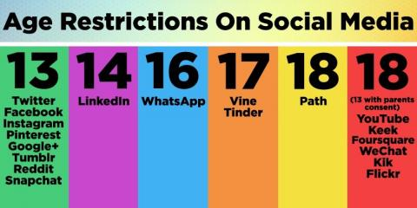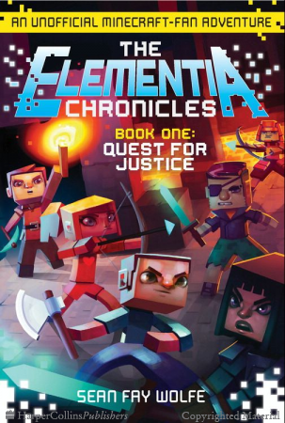

**An interview with Mrs Broad**

Q: What’s your favourite colour?

A: Purple

Q: What car do you have?

A: Fiat 500

Q: If you had one million pounds what would you do with It

A: Go on lots of holidays

Q: If you were not a teacher what would you be

A: Book editor

Q: What is your favourite lesson to teach

A: PSHE

Q: What is your favourite food?

A: Pizza

By Shannon Pierce and Charlie Oley

**How to deal with online bullying**

To some people bullying is physical, but think again. What if its online bullying? Here are our top three tips for dealing with online bullying:

1. Make sure you have permission to use social media and you are the legal age.
2. If you get an inappropriate picture sent to you, make sure you tell an adult.
3. If you are worried about any communication you get you can always call Childline 0800 1111.

By Jay Kinzett and Amelia Fairhurst

**The Elementia Chronicles Quest for Justice Book Review**

In this book, three Minecraft players who go by the names of Stan, Kat and Charlie embark on an epic quest to overthrow the tyrannical King Kev. On their journey, Kat, Stan and Charlie make friends with numerous quirky characters, like DZ, who helps them out in a hostile swarm; The Nether Boys and other characters quickly build a relationship with Stan- and there are many others!

When the final battle occurs, Stan has to take down the King in the castle to save the server of Elementia and bring justice to the server.

I’d recommend this book for Minecraft Fans aged 9-11 (or to 14) because of some dramatic content but on the whole it is AMAZING.

By Ruby Yates