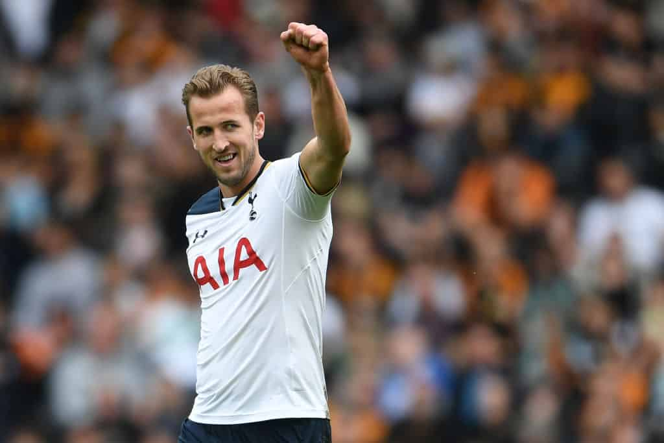

23rd Edition – 19th June 2018

**Grenfell remembers one year on**

One year ago on the 14th of June, 2017, a fire broke out in the early hours of the morning.

Firefighters arrived within 6 minutes of the blaze starting, but were unable to stop it from spreading- all through 24 floors.

**Why is this so important?**

72 people lost their lives, and many more were injured and lost their homes that day, as the tower was completely destroyed…to top it off, many nearby houses were destroyed in the blaze.

The chief fire captain of London Fire Brigade described it as unprecedented- this means that something like that had never happened before.

**How are people remembering?**

People have gone on memorial walks through cities and towns.

Many buildings were lighted in green in London on the evening of the day when the fire occurred- like 10 Downing Street and the London Eye.

We remember those unfortunate 72 lives that were lost that night.

We will remember them.

By Ruby Yates, Riley Chalke and Wilf HG

By children, for children.

DILTON TIMES

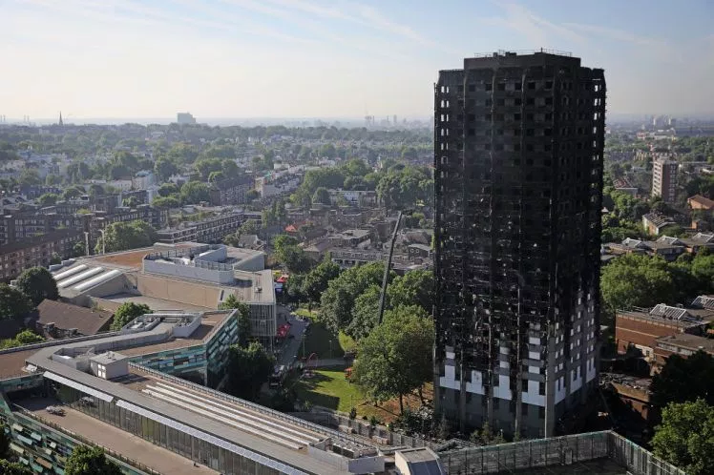

**King Harr Kane carries England team!**

England’s first football World Cup match took place in Russia last night with Harry Kane scoring against Tunisia. Kane was insane with a goal to bring them closer to winning the precious cup. The cup was last held by England in 1966. England are currently in Group G of the first round. Their first game, last night, was against Tunisia. The final score was only 2:1 to England.

England started strong with a goal in the eleventh minute, scored by Harry Kane. The game was nail-bitingly tense at half time when Tunisia scored a goal near the second half, equalising the score. Nonetheless, Kane was again the hero of the hour with last minute header to carry England into their first win of the cup.

England next play Panama on Sunday 24th June at 1PM. Hopefully this game will be another point scorer and move England closer to the cup and get another star on their shirts.

Go England!

By Darcie Loh and Oscar Froggatt

# **Minecraft: Story mode season 2 Game Review**

Minecraft Story Mode is a fun, popular and very enjoyable game. Come and see how truly amazing this adventurous game will blow your mind with excitement and curiosity. There are four episodes in this season. Here they are:

* Hero In Residence – Episode 1
* Giant Consequences – Episode 2
* Jailhouse Block – Episode 3
* Below The Bedrock – Episode 4

During the game you will meet friends and heroes ( Some friends are heroes ) and get through a journey as a character called Jesse ( Bearing in mind you can choose gender ). Jesse’s friends are people called Petra, Lukas, Radar, Axel and Olivia. These friends will help you make decisions and complete the episode. So when you get home, turn on your tablet/laptop and play the most amazing game Minecraft Story Mode.

By Harry Lawrence and Sofia Corgiolu

**New ten pence pieces!**

New ten pence pieces have been unveiled by the Royal Mint, the company who make the nation’s coins.

These gorgeous new coins have letters of the alphabet on them- the B one in particular has James Bond’s logo on it- 007.

We think they look awesome, but what about you?

By Riley Chalke



**Captain Underpants: The first epic movie**

TRA LA LAAAAAAAAAAAA! Faster than a speeding waist band and stronger than boxer shorts, Mr. Krupp, the worst principal in the world( voiced by Ed Helms ) was unexpectedly hypnotised by George Beard( voiced by Kevin Hart ) and Harold Hutchins( voiced by Thomas Middleditch ) to become the amazing CAPTAIN UNDERPANTS! Unfortunately he has no super powers (well that’s a problem) he meets an evil mastermind (that’s an even bigger problem) called Professor Poopypants (voiced by Nick Kroll) using Melvin’s (voiced by Jordan Peele) creation the Turbo Toilet 2000 and makes it colossal using his size-orator! Watch the film to find out what happens next. You’ll laugh your pants off!

By Stefano Corgiolu and Archie Peters

**Riddle Time!**

What loses its head in the morning and gets it back in the evening?

By Caroline South

**Is this the last straw? No, wait. Plastic straw…**

The fast food restaurant we love has banned an item for drinks-plastic straws!

This ban will start from September and McDonalds will only be using paper from then onwards. The ban will not be world-wide at first, but will soon be in McDonalds all over the UNIVERSE- ok not quite the UNIVERSE but the world.

Did You Know?

They say they use 1.8 million straws per day! That’s nearly 1 straw per every 4 people in the UK!

Most straws are made from plastics called polypropylene and polystyrene which takes years to decompose if not recycled.

The UK use about 8.5 BILLION straws at McDonalds every year! I can’t believe it! That’s a lot of straws people! Wow…

By William Slarke and Caroline South