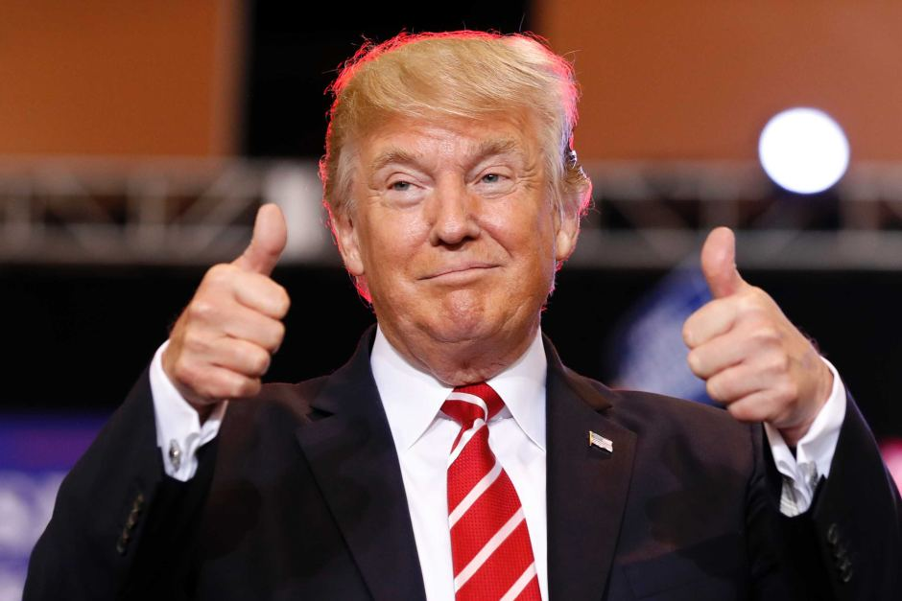

Twentieth anniversary edition!

**North and South Unite!**

**(Korea not the directions)**

Kim Jong-Un, the North Korean leader, has been causing uproar alongside Donald Trump in the news recently.

However, he has just met the South Korean leader for the first time in a decade (10 years!!)

Korea was split in two after the Korean war, which brought much pain and hard suffering to those involved.. and to those related to those involved.

The two sections of Korea have been living in mutual anger (well, the North have).

The news of the two uniting to meet at the closed borders has sparked hopes of a new friendship between the new countries.

Also, the dreaded North Korean nuclear test site is closing later this month.

Let’s hope this peace continues!

By William Slarke and Caroline South

20th Edition – 1st May 2018

By children, for children.

DILTON TIMES

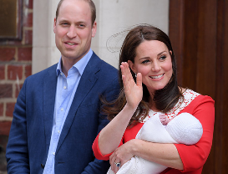

**Royal Baby Update!**

The royal baby has been named.

The Duchess of Cambridge is pleased to announce that her bouncing baby boy’s name is Louis- just like the Irish legend Louis Walsh (Although not as old, of course)!

People are happy with the news and are looking forward to seeing little prince Louis on the throne.

By Darcie Loh and Oscar Froggatt

**Should we put a red carpet out for Trump?**

In mid-July Donald Trump’s coming to England! Should we get a red carpet out? If you didn’t hear, Trump is the president of the United States of America. Yes, the orange tanned man is the head of the USA and there are a lot of changes underway!

Trump arranged to visit the UK previously in February but cancelled. He said that he wasn’t happy with the US embassy office and its location so didn’t want to visit. So should we welcome him back with open arms again after his rude cancellation?

Did you know: that rumours have come in that Trump is planning to paint the white house gold then it would be the Gold house!

By Riley Chalke and Archie Peters

# **Should we be allowed to wear onesies at the cinema?**

In New Zealand, the cinemas have banned wearing pyjamas or onesies in any of them! So people have been thinking, if New Zealand have, then maybe the United Kingdom should. The cinema says that they will improve the dress standards in the town. So they put on a vote if we should be able to wear onesies and pyjamas in the movie theatre or to not be allowed to wear them.

Lots of people had voted to choose to or not. The results were that 18% voted that we shouldn’t wear them and 82% voted we should.

What do you think?

By Theo Baalham

and Harry Lawrence

-You can carry it everywhere you go, and it won’t get heavy. What is it?

-There was a man who was born before his father, killed his mother and married his sister. Yet, there was nothing wrong with what he had done. Why?

**GREATER DEPTH**

Detective James needs access to a door which can only be opened by a code. The code is 7 characters long and uses letter and numbers. There was a sign above the door saying, “You force heaven to be empty.” Break the code.

By Caroline South and William Slarke

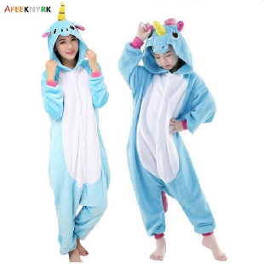

# **Animal crossing review**

Mix animals, mayoral duties and a cute town together, and what do you get? Animal Crossing New Leaf- Welcome Amiibo!

The game involves you, a villager, arriving in a town via train. You get to choose your town’s layout and name on the train before arriving- to be greeted by a group of talking villagers and a golden dog- Isabelle, your mayoral secretary!

In the game, you collect bells, which can buy clothes and items to customise your very own house. With so many different events- New Year’s fireworks, August firework shows, Toy Day (Christmas) and Festivale- you’ll never get bored of this colourful, happy game!

By Ruby Yates

**Bad Dad Review**

Bad Dad is a book by David Williams. He has done 11 other books, some of which have won prestigious writing awards!

In the book, Frank (the son of Gilbert Goodie, his dad), sneaks out and witnesses his dad conversing with Mr. Big (a small crime leader), Fingers and Thumbs. When Gilbert is sent to jail, Frank and his dad have to come up with a devious plan to return the stolen money and clear his father’s name.

Can they do it, though?

By Charlie Oley

**Riddles are back!**

You can do any riddle, just KS2 riddles are harder.

**Riddles- KS1**

-Why is Europe like a frying pan?

-How do you spell COW with 13 letters?

-What time does a tennis player get up?

-Which is the only way a leopard can change its spots?

-What can you catch but never throw?

**Riddles- KS2 (warning, difficult)**

-The man who built it doesn’t want it, the man who wants it doesn’t need it, the man who needs it doesn’t know it. What is it

-Name an 8 letter word that has kst in the middle, in the middle, and at the end.