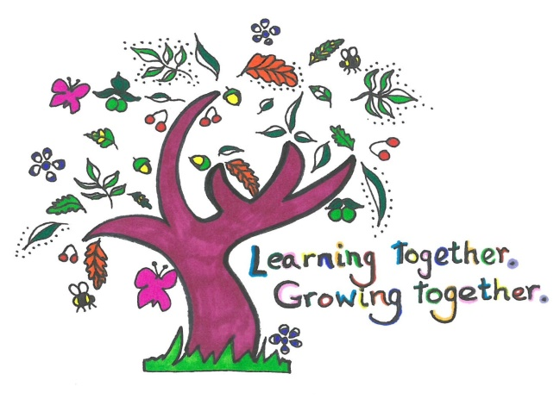

**Our Mission**

**At Dilton Marsh C of E Primary School we will,**

* teach a creative, exciting and innovative curriculum that sets high standards and recognises and respects our diverse backgrounds and needs
* ensure that all children are safe, secure, happy and healthy
* through a framework of Christian values, help children to develop as responsible and caring citizens

* encourage children to become independent learners with lively, enquiring minds and a sense of their own identify
* deliver quality first teaching
* collaborate with the wider community
* promote a high standard of behaviour which demonstrates respect towards and tolerance of others
* celebrate and share success and achievement
* provide a wide range of focused, effective and creative learning experiences that are fun and enjoyable
* develop the ability to live and work both cooperatively and independently