

**New Behaviour Policy**

Dilton Marsh has a new behaviour system which has been put in place.

Problems have become an issue at school, and to make sure that everyone’s smiling, we have created stages. So the focus is on those who do the right thing.

Stage one is a verbal warning you can deserve this for doing the following of these things like: talking over the teacher, fidgeting when told not to touch anything etc. Hopefully people never go on to the other stages but if they do there are consequences to follow.

We hope that this will mean that people will see us as respectful, responsible, polite, kind, persevering and doing our best.

By Caroline South and Amy Cooper

15th Edition – 16th January 2017

By children, for children.

DILTON TIMES

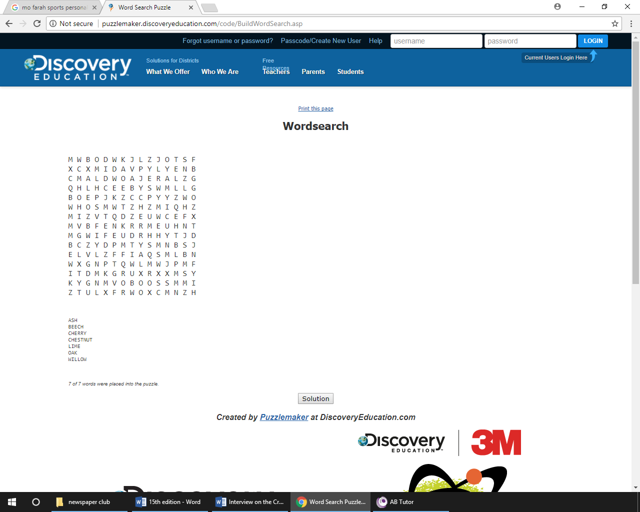

**Black holes can burp?!**

You know when you’re enjoying your meal in peace, and that person burped, interrupting your enjoyment?

Well, turns out we’re not the only things that do! Black Holes can, too!

Black Holes are holes in space where gravitational force helps it absorb light, air and cosmic gas. But when Black Holes absorb too much, they release a ripple of energy- just like burping! And sometimes, they burp more than once.. which is kind of gross, but kind of cool, too!

So next time that annoying noise pops up, remind yourself- Black Holes have bad table manners, too!

By Ruby Yates and Wilf HG



# **Book review on The Creakers by Tom Fletcher**

The Creakers is a book where Lucy Dungston lost her parents and she has to be the leader of all the children in the town. The Creakers are a silly monster that lives under our beds (but they are not real) Lucy tried every channel on T.V and she even went to0 SCHOOLThe Creakers come up from the Woleb and Lucy, Norman and Ella set a trap. Later on in the story Lucy puts her goggles one because the Creakers have sleep dust and it doesn’t affect goggles. I would rate this story 10/10 because it is really good and it is extremely descriptive.

By Charlie Oley

By Charlie Oley

**Maddison and Theo’s fantastic fact file!**

1. The average person laughs 15 times per day.
2. If the human eyes were more sensitive, the sky would be violet.
3. Peanuts are an ingredient of dynamite.
4. There are approximately 13,914,291,404 human legs in the world.
5. In the body there are roughly 6 bars of soap.
6. The oldest person lived up to 122 and died from a burning cake because it had too many candles!

By Theo Baalham and Madison Hibberd

**Sports personality**

Mohamed Farah won BBC personality award winning his third 10,000m gold medal at the world athletic championships in London. He was the first long distance runner to win SPOTY since Paula Radcliffe since 2002! The runner failed to make even the top three for the award since 2010 so he was shocked to finally win first place.

By Rebekah Slarke and Kian Pierce

**An interview with…**

**Miss Roberts**

Q. What’s your favourite colour?

A. Yellow

Q. What’s your favourite food?

A. Pasta

Q. What’s your favourite lesson?

A. Art

Q. What’s your favourite Christian value?

A. Perseverance.

Q. What’s your favourite book?

A. Gangsta Granny.

Q. What’s your favourite film?

A. The Holiday

By Oscar Froggatt and Lauren Cooke