Safeguarding and Child Protection Policy.
Dilton Marsh Church of England Primary School recognises its responsibilities for safeguarding and child protection.

Policy agreed (date): | September 2020
Policy published (including on website) (date): | September 2020
Next review (date): | September 2021

Key Safeguarding Personnel
Role | Name | Tel. | Email
Headteacher | Jill Hibbs | 01373 822902 | jh@diltonmarsh.wilts.sch.uk
Designated Safeguarding Lead (DSL) | Sharon Broad | 01373 822902 | sb@diltonmarsh.wilts.sch.uk
Deputy DSL(s) (DDSL) | Jill Hibbs  Caroline Tout | 01373 822902 | jh@diltonmarsh.wilts.sch.uk  ct@diltonmarsh.wilts.sch.uk
Nominated Governor | Melinda Graves | 01373 822902 | mg@acorntrust.wilts.sch.uk
Chair of Governors | Melinda Graves | 01373 822902 | mg@acorneducationtrust.wilts.sch.uk
Designated Teacher for Looked After Children | Sharon Broad | 01373 822902 | sb@diltonmarsh.wilts.sch.uk
The key safeguarding responsibilities within each of the roles above are set out in Keeping Children Safe in Education (2020)
Children’s Social Care referrals:  Multi-Agency Safeguarding Hub (MASH):  Out of hours: |  |  |  | 0300 456 0108  0300 456 0100

If you believe a child is at immediate risk of significant harm or injury,
you must call the police on 999.
Introduction
Dilton Marsh Church of England Primary School is committed to safeguarding and promoting the welfare of children.
We will fulfil our local and national responsibilities as laid out in the following key documents:
- Working Together to Safeguard Children (2018)
- Keeping Children Safe in Education (2020)
- Non-statutory interim guidance: COVID-19: safeguarding in schools, colleges and other
- The Procedures of Safeguarding Vulnerable People Partnership (formerly WSCB)
- Information sharing - Advice for practitioners providing safeguarding services to children, young people, parents and carers (2018)

The aim of this policy is to ensure:
- all our pupils are safe and protected from harm.
- safeguarding procedures are in place to help pupils to feel safe and learn to stay safe.
- adults in the school community are aware of the expected behaviours and the school’s legal responsibilities in relation to safeguarding and child protection.

Scope
Safeguarding children is defined as:
- ensuring that children grow up with the provision of safe and effective care
- acting to enable all children to have the best life chances
- preventing impairment of children's mental and physical health or development and
- protecting children from maltreatment.
The term ‘safeguarding children’ covers a range of measures including child protection procedures. It
encompasses a preventative approach to keeping children safe that incorporates pupil health and
safety; school behaviour and preventing bullying; supporting pupils with medical conditions; personal,
health, social economic education; providing first aid and site security.
Consequently, this policy is consistent with all other policies adopted by the governors and should be
read in alongside the following policies relevant to the safety and welfare of our pupils:

- Behaviour policy  - Anti-bullying policy | - Staff Code of Conduct  (for safer working practice) | - Teaching and Learning policy
- Equality Statement | - Whistleblowing policy | - SEND policy
- Sex and relationship education/Health Education (PSHE) | - Health and Safety  - Online Safety

This policy applies to all staff in our school.
For the purposes of this policy:
- Staff refers to all those working for or on behalf of the school, full time or part time, in a paid or voluntary capacity. A volunteer is a person who performs an activity that involves spending time, unpaid in school (except for approved expenses).
- A volunteer is a person who performs an activity that involves spending time, unpaid in school (except for approved expenses).
- Parent refers to birth parents and other adults who are in a parenting role, for example step-parents, foster carers and adoptive parents.
- Child refers to all children on our school roll and any child under the age of 18 who comes into contact with our school. This includes unborn babies.
Any safeguarding concerns or disclosures of abuse relating to a child at school or outside of school hours are within the scope of this policy.

Expectations
All staff are:
- familiar with this safeguarding policy and have an opportunity to contribute to its review.
- alert to signs and indicators of possible abuse.
- able to record and report concerns as set out in this policy.
- able to deal with a disclosure of abuse from a pupil.
- involved in the implementation of individual education programmes, integrated support plans, child in need plans and interagency child protection plans as required.

Governors
In addition, all staff have read and understood Part 1 of the latest version of Keeping Children Safe in Education (KCSiE 2020). All staff working directly with children have also read Annex A.
The governors will make sure that our policies and procedures are in line with national and local safeguarding requirements. Governors will work with the senior leaders to make sure the following safeguarding essentials are in place:

Training/Teaching | Policy/Procedures | Staffing
Children taught about online  safety  Staff Code of Conduct  D/DSL training  KCSiE Part 1 (and Annex A for staff working directly with children)  Looked After Children (LAC)  Online safety training for staff  Preventing Radicalisation  Staff training  Whistleblowing | Child voice  Children Missing out on  education and Children Missing Education (CME)  Concerns about staff conduct  Dealing with a child at immediate risk  Early help  Female Genital Mutilation (FGM)  Honour based abuse (HBA)  Peer on Peer abuse  Mental Health  Reporting abuse /SVPP procedures  SEND and safeguarding  Staff contribution to policy  Safeguarding policy review | Designated Safeguarding Lead (DSL)  Deputy Designated  Safeguarding lead (DDSL)  Designated LAC teacher (even if there are no LAC on roll)
Allegations management
Our chair of governors is responsible for liaising with the local authority Designated Officer for Allegations (DOfA) and other partner agencies in the event of an allegation of abuse being made against the headteacher.
See also ‘Managing allegations against adults’ flow chart.
Audit
The nominated governor (NG) for safeguarding will liaise with the headteacher and the D/DSL to complete an annual safeguarding audit return to the local authority.
Safer Recruitment
Our governors monitor the school’s safer recruitment practice.

The role of the Designated Safeguarding Lead (DSL)

The DSL is a senior member of staff, from the school leadership team, designated to take lead responsibility for:
- Managing all child protection issues (Headteacher/Principal leads on allegations against staff), including referring cases to the MASH, or to the Channel programme where there is a radicalisation concern
- Liaise with others within the school (Headteacher, Nominated Governor, staff and volunteers, parents)
- Support staff who make referrals to the MASH, or Channel programme
- Working in partnership with other agencies such as the local authority, MASH, police, Channel, SVPP
- Undertake training
- Raise awareness of safeguarding, by regularly review the safeguarding policy and procedures, ensure availability to staff and parents
- Induction of staff and volunteers/staff training/ensure staff are aware of safeguarding policy and procedure
- Maintain and transfer safeguarding files.

Information sharing –internal process
Information concerning students at risk of harm will be shared with all members of staff on a “need to know” basis. The DSL will make a judgement in each individual case about who needs and has a right to access particular information.

For more information about the role of the DSL (and DDSL), please refer to Annex B of KCSiE 2020.

What constitutes child abuse and neglect?

All adults who work or volunteer with children should be able to identify concerns about child abuse.

The types of abuse are:

Main categories of abuse: | Specific safeguarding issues*:  *For other specific safeguarding issues, please see Keeping Children Safe in Education 2020 (p.12-13).
- Physical abuse  - Emotional abuse  - Sexual abuse  - Neglect | - Child Sexual Exploitation (CSE)  - Child Criminal Exploitation (CCE)  - ‘honour based’ abuse (HBA)  - Female Genital Mutilation (FGM)  - Preventing radicalisation  - Children missing education  - Peer on peer abuse  - Serious violence  - Mental Health

Mandatory Procedure
Safer recruitment
All staff are subject to safer recruitment processes and checks and we follow the guidance set out in Part 3 of KCSiE.(2020).
At Dilton Marsh Church of England Primary School we scrutinise all applications for paid or voluntary posts. We undertake interviews and make appropriate checks through the Disclosure and Barring Service (DBS). We maintain a single central record (SCR) of the essential checks as set out in KCSiE, that have been carried out and certificates obtained. The SCR applies to:
- all staff (including supply staff, and teacher trainees on salaried routes) who work at the school.
- all members of the Acorn Education Trust.
See also Training.

Staff Code of Conduct (for safer working practice)
Dilton Marsh Church of England Primary School is committed to positive academic, social and emotional outcomes for our pupils underpinned by a strong safeguarding ethos. We are equally committed to the protection and welfare of our staff, who are expected to adhere to the highest standards of professional behaviour.
The Staff Code of Conduct sets out staff behaviours that should be avoided as well as those that constitute safe practice and supports our commitment to safeguarding children.
Teaching staff are additionally expected to act within the guidance of the 'personal and professional conduct' section of the Teachers' Standards.
Visitors
All visitors complete a signing in/out form, wear a school ID badge and are provided with key safeguarding information including the contact details of safeguarding personnel in school.
Scheduled visitors in a professional role (eg fire officer) are asked to provide evidence of their role and employment details (usually an identity badge) upon arrival at school.
If the visit is unscheduled and the visitor is unknown to the school, we will contact the relevant organisation to verify the individual’s identity, if necessary.
Curriculum – teaching about safeguarding
Our pupils access a broad and balanced curriculum that promotes their spiritual, moral, cultural, mental and physical development, and prepares them for the opportunities, responsibilities and experiences of life.
We provide opportunities for pupils to develop skills, concepts, attitudes and knowledge that promote their safety and well-being. The PSHE and citizenship curriculum specifically includes the following objectives:
- Developing pupil self-esteem and communication skills
- Developing strategies for self-protection including online safety
- Developing a sense of the boundaries between appropriate and inappropriate behaviour in adults and within peer relationships (positive relationships and consent)
We use the Jigsaw, the mindful approach to PSHE to teach Relationship, Health, Safety and citizenship education.

Early help
At Dilton Marsh Church of England Primary School, all our staff can identify children who may benefit from early help as a problem emerges, and discuss this with the D/DSL.
The D/DSL uses
- the guidance on the Wiltshire Pathways website and the Digital Assessment and Referral Tool as appropriate as part of a holistic assessment of the child’s needs.
- the Multi-Agency Thresholds for Safeguarding Children on the WSCB website about suitable action to take when a pupil has been identified as making inadequate progress or having an unmet need.
Identifying the signs
All staff know how to recognise, and are alert to the signs of neglect and abuse. Definitions of abuse, set out in ' What to do if you’re worried a child is being abused - Advice for practitioners’ (2015) and 'Keeping Children Safe in Education' (2020) along with notes from Safeguarding training, are important reference documents for all staff. Every member of staff is provided with a copy of Part 1 of KCSiE which they are required to read and which also includes supporting guidance about a number of specific safeguarding issues. Staff who work directly with children are also required to read Annex 1 of KCSiE (2020).
Responding to concerns/disclosures of abuse
Flowcharts provided by the SVPP that set out the required procedure for staff to follow when they have a safeguarding concern about a child are displayed in the staffroom and adult cloakrooms for easy reference.
Staff adhere to the following Dos and Don’ts when concerned about abuse or when responding to a disclosure of abuse.
Dos:
- create a safe environment by offering the child a private and safe place if possible.
- stay calm and reassure the child and stress that he/she is not to blame.
- tell the child that you know how difficult it must have been to confide in you.
- listen carefully and tell the child what you are going to do next.
- use the ‘tell me’, ‘explain’, ‘describe’ and/or mirroring strategy.
- tell only the Designated or Deputy Safeguarding Lead.
- record in detail using MY CONCERN (on a secure school based computer, laptop or ipad) without delay, using the child’s own words where possible.
Don’ts:
- take photographs of any injuries.
- postpone or delay the opportunity for the pupil to talk.
- take notes while the pupil is speaking or ask the pupil to write an account.
- try to investigate the allegation yourself.
- promise confidentiality eg say you will keep ‘the secret’.
- approach or inform the alleged abuser.
All staff record any concern about or disclosure by a pupil of abuse or neglect and report this to the D/DSL using MY CONCERN. It is the responsibility of each adult in school to ensure that the D/DSL receives the record of concern without delay. In the absence of the D/DSL, staff members know to speak directly to the MASH.
In some circumstances, the D/DSL or member of staff seeks advice by ringing the MASH for advice. (Appendix 3)
The D/DSL will liaise with safeguarding partners and work with other agencies in line with Working Together (2018) and will refer to National Police Chief’s Council guidance for schools to understand when they should consider calling the police.
During term time, the DSL or a DDSL is always available during school hours for staff to discuss any safeguarding concerns.
The voice of the child is central to our safeguarding practice and pupils are encouraged to express and have their views given due weight in all matters affecting them.
Missing children and children missing education
Staff report immediately to the D/DSL, if they know of any child who may be:
- Missing – whereabouts unknown or
- Missing education – (compulsory school age (5-16) with no school place and not electively home educated)
The designated teacher for LAC discusses any unauthorised/unexplained absence of Looked After Children with Virtual School when required.
The DSL shares any unauthorised/unexplained absence of children who have an allocated social worker within 24 hours.
Children who do not attend school regularly can be at increased risk of abuse and neglect. Where there is unauthorised/unexplained absence, and after reasonable attempts have been made to contact the family, we follow the SVPP procedure and refer to the MASH team as appropriate.
Where there are no known welfare concerns about a pupil, we follow our procedures for unauthorised absence and report concerns to the Education Welfare Service.
Special Education Needs and Disability (SEND)
Pupils with additional needs face an increased risk of abuse and neglect. Staff take extra care to interpret correctly apparent signs of abuse or neglect. We never assume that behaviour, mood or injury relates to the pupil’s additional needs without further exploration. Staff understand that additional challenges can exist when recognising abuse and neglect in pupils with SEND, including communication barriers.
In our school, pupils with SEND are encouraged to discuss their concerns. The D/DSL works with the Special Educational Needs Co-ordinator (SENCo) to identify pupils with additional communication needs and whenever possible, these pupils are given the chance to express themselves to a member of staff with appropriate communication skills.
Female Genital Mutilation (FGM)
FGM is illegal in the UK and a form of child abuse with long-lasting harmful consequences.
Staff will inform the D/DSL immediately if they suspect a girl is at risk of FGM.
We will report to the police any ‘known’ cases of FGM to the police as required by law.
Peer on Peer abuse
All our pupils have a right to attend school and learn in a safe environment. Staff recognise that while both boys and girls can abuse their peers, it is more likely that girls will be victims and boys instigators of such abuse. Peer on peer abuse is not tolerated, passed off as “banter” or seen as “part of growing up”.
It is likely to include, but not limited to:
- bullying (including cyber bullying)
- verbal abuse
- gender based violence/sexual assaults
- sexting or
- initiation/hazing type violence and rituals
- ‘upskirting’ or any picture taken under a person’s clothing without them knowing to obtain sexual gratification or cause humiliation or distress.

Consequently, peer on peer abuse is dealt with as a safeguarding concern and not managed through the systems set out in the school behaviour policy.
Our policy on Peer on Peer abuse sets out procedures to minimise the risk of peer on peer abuse;
• how allegations of peer on peer abuse will be recorded, investigated and dealt with;
• clear processes as to how victims, perpetrators and any other child affected by peer on peer abuse will be supported;
• a clear statement that abuse is abuse and should never be tolerated or passed off as “banter”, “just having a laugh” or “part of growing up”;
• recognition of the gendered nature of peer on peer abuse (i.e.), but that all peer on peer abuse is unacceptable and will be taken seriously; and
• the different forms peer on peer abuse can take, such as:
• sexual violence and sexual harassment.
• physical abuse such as hitting, kicking, shaking, biting, hair pulling, or otherwise causing physical harm;
• sexting (also known as youth produced sexual imagery): the policy should include the school or college’s approach to it. The department provides searching screening and confiscation advice for schools. The UK Council for Child Internet Safety (UKCCIS) Education Group has published advice for schools and colleges on responding to sexting incidents; and
• initiation/hazing type violence and rituals.

Consequently, peer on peer abuse is dealt with as a safeguarding issue, recorded as such and not managed through the systems set out in the school behaviour policy.
Any child affected by peer on peer abuse, will be supported through the school’s pastoral system and the support will be regularly reviewed.
We minimise the risk of peer on peer abuse by providing:
- a relevant curriculum, that helps children to develop their understanding of acceptable behaviours, healthy relationships and keeping themselves safe. The curriculum is updated to reflect changes in legislation, specifically this year pupils will be taught for the first time that ‘upskirting’ is now a criminal offence. The PSHE, PE and RE curriculum also relates to and reflects changes from the mandatory teaching of Relationship Education and Health Education.
- established/publicised systems for pupils to raise concerns with staff, knowing they will be listened to, supported and valued, and that the issues they raise will be taken seriously.

The DSL liaises with other professionals to develop robust risk assessments and appropriate specialist targeted work for pupils who are identified as posing a potential risk to other children. This is done using a Contextual Safeguarding approach to ensure assessments consider risks posed by any wider environmental factors present in a child’s life.

Domestic abuse
Staff understand that domestic abuse is any incident or pattern of incidents of controlling, coercive, threatening behaviour, violence or abuse between those aged 16 or over who are, or have been, intimate partners or family members regardless of gender or sexuality. The abuse can encompass but is not limited to: psychological; physical; sexual; financial; and emotional harm.
The DSL liaises with partner agencies as part of ‘Encompass’ in Wiltshire. When police are called to an incident of domestic abuse, where there are children in the household who have experienced the domestic incident, the DSL ensures the organisation receives up to date relevant information about the child’s circumstances and will ensure key staff provide emotional and practical support to the child according to their needs.
Mental health
All staff are aware that mental health problems can be an indicator that a child has suffered or is at risk of suffering abuse, neglect or exploitation.
Staff understand that:
- abuse and neglect, or other potentially traumatic adverse childhood experiences can have a lasting impact throughout childhood, adolescence and into adulthood. Staff are aware of how
- these experiences can impact on children’s mental health, behaviour and education.
- they have a duty to observe children day-to-day and identify those whose behaviour suggests that they may be experiencing a mental health problem or be at risk of developing one.
If staff have a mental health concern about a child that is also a safeguarding concern, they will report this concern using the agreed reporting mechanisms.

Preventing radicalisation
Protecting children from the risk of radicalisation is seen as part of schools’ wider safeguarding duties, and is similar in nature to protecting pupils from other forms of harm and abuse.
Staff use their judgement in identifying pupils who might be at risk of radicalisation and speak to the D/DSL if they are concerned about a pupil. The D/DSL will always act proportionately and this may include making a Prevent referral to the Channel support programme or to the MASH.

Serious violence
We are committed to success in learning for all our pupils as one of the most powerful indicators in the prevention of youth crime.
Our curriculum includes teaching conflict resolution skills and understanding risky situations to help our children develop the social and emotional skills they need to thrive.
Staff are trained to recognise both the early warning signs that pupils may be at risk of getting involved in gangs as well as indicators that a pupil is involved in serious violent crime. They are also aware of the associated risks and know the measures put in place to minimise such risks.
Off site visits and exchange visits
We carry out a risk assessments prior to any off-site visit and designate the specific roles and responsibilities of each adult, whether employed or volunteers.
Where there are safeguarding concerns or allegations that happen offsite, staff will follow the procedures described above and in Appendix 2
Where there are safeguarding concerns or allegations that happen offsite, staff will follow the procedures described above and in the SVPP flowcharts as appropriate. A copy of the flowcharts is taken on off-site visits for reference.

Exceptional operating circumstances
If the school is required to change the way we offer our provision to children due to exceptional circumstances eg during a pandemic lockdown, staff responsibilities to remain alert to the signs and risks of abuse to children will continue to apply. In such circumstances:
The DSL will:
- work closely with social care and partner agencies to support children in these circumstances and to identify children who may be at risk for the first time and/or benefit from additional support
- use specific local and national guidance about safeguarding in such circumstances to inform practice and will ensure staff, children, and families are provided with written:
- amended DSL arrangements as required (names, location and contact details)
- temporary changes to procedures for working with children eg online.
- amended procedures for reporting concerns
- safeguarding training arrangements
- timescales for such changes so that all children, families and staff understand when such arrangements will end, and arrangements revert to those in place prior to the events leading to the need for the temporary changes.
We will ensure the curriculum we offer during such circumstances, continues to promote learners’ spiritual, moral, cultural, mental and physical development.

Record keeping and information sharing
The school will:
- liaises with partner organisations (alternative provisions, Wiltshire Council, Virtual School) to ensure any safeguarding records for learners are shared on transition:
  - by the setting/school/organisation previously attended by the child.
  - by our DSL when the child leaves our school.
For any child dual-registered with another school/setting/organisation, the DSL liaises regularly with the DSL at that base to ensure information is shared in the child’s best interests. This includes contextual safeguarding information about relationships that young people form in their neighbourhoods, schools and online to enable assessment and intervention to happen within these extra-familial contexts.
- keeps clear records of all pupil safeguarding and child protection concerns using MY CONCERN including actions taken and outcomes as appropriate.
- ensure all paper based pupil safeguarding and child protection records are kept securely in a locked location.
- Ensure that DSL/DDSL review, action and respond to all MY CONCERN logs as they are sent.
- Ensure that My Concern is reviewed at least termly via Supervision.
- ensure the records incorporate the wishes and views of the pupil.

The D/DSL acts in accordance with Information Sharing – Department for Education (DfE) (2018) and in line with Wiltshire’s Record Keeping Guidance which includes details about file retention.
Information about pupils at risk of harm is shared with members of staff in keeping with the seven golden rules to sharing information in the DfE guidance.
The D/DSL makes a judgement in each case.
We are committed to work in partnership with parents and carers. In most situations, we will discuss initial concerns with them. However, the D/DSL will not share information where there are concerns that if so doing would:
- place a child at increased risk of significant harm
- place an adult at increased risk of serious harm
- prejudice the prevention, detection or prosecution of a serious crime
- lead to unjustified delay in making enquiries about allegations of significant harm to a child, or serious harm to an adult.
When we become aware that a pupil is being privately fostered, we remind the carer/parent of their legal duty to notify Wiltshire Children’s Social Care. We follow this up by contacting Children’s Social Care directly.
Escalation of concerns-
Effective working together depends on an open approach and honest relationships between colleagues and between agencies.
Staff must be confident and able to challenge decision-making as an entirely legitimate activity, as part of our professional responsibility to promote the best safeguarding practice. Staff are encouraged to press for re-consideration if a child’s situation does not appear to be improving or if they do not feel a decision is right. In such cases the SVPP case resolution protocol is used.
If we are on the receiving end of a professional challenge, we see this as an opportunity to reflect on our decision making.
Whistleblowing
All staff can raise concerns about poor or unsafe practice and potential failures in the school safeguarding regime. Our whistleblowing procedures, which are reflected in staff training and our Code of Conduct, are in place for such concerns to be raised with Headteacher.
If a staff member feels unable to raise an issue with Headteacher or feels that their genuine concerns are not being addressed, other whistleblowing channels are open to them:
- The NSPCC whistleblowing helpline
Staff can call: 0800 028 0285 from 08:00 to 20:00, Monday to Friday, or e.mail help@nspcc.org.uk.
- A member of the governing body: Melinda Graves mg@acorntrust.wilts.sch.uk
- Executive Headteacher: sp@acorneducationtrust.com

Managing allegations against adults
Dilton Marsh Church of England follows the procedures set out in the SVPP Allegations Against Adults Flow Chart which is displayed in the staffroom and adult cloakrooms for easy reference.
Where anyone in the school has a concern about the behaviour of an adult who works or volunteers at the school, including supply staff, they must immediately consult the Headteacher/Principal who will refer to the Designated Officer for Allegations (DOFA).
Any concern or allegation against the Headteacher/Principal will be reported to the Chair of Governors without informing the Headteacher/Principal.
All staff must remember that the welfare of a child is paramount and must not delay raising concerns by a report that could jeopardise their colleague’s career.
Any allegation of abuse will be dealt with in a fair and consistent way that provides effective protection for the child and at the same time supports the person who is the subject of the allegation.
All members of staff and volunteers have read, signed to confirm they have understood the Acorn Trust’s Code of Conduct (for safer working practice).

Online Safety
Dilton Marsh Church of England Primary School recognises the importance of educating children in terms of Online Safety in an increasingly social media led world. As a result of this we have a deputy safeguarding lead Caroline Tout who is responsible for Online safety. For further information please see:
Online safety action plan.
Online safety policy.
Responsible Use Policy.

Training
All members of staff and volunteers have read, signed and understood the school’s Code of Conduct supplied by the Acorn Education Trust.
Induction
The welfare of all our pupils is of paramount importance. All staff including volunteers are informed of our safeguarding procedures including online safety, at induction. Our induction also includes:
- Plan of support for individuals appropriate to the role for which they have been hired
- Confirmation of the conduct expected of staff within the school – our Staff Behaviour Policy
- Opportunities for a new member of staff to discuss any issues or concerns about their role or responsibilities
- Confirmation of the line management/mentor process whereby any general concerns or issues about the person’s ability or suitability will be addressed.
Safeguarding training
This training is for all staff and is updated every year to ensure staff understand their role in safeguarding. Any member of staff not present at this whole school session will receive this statutory training requirement on their return.
In addition, all staff members receive safeguarding and child protection updates (for example, via email, e-bulletins, weekly staff meetings) twice yearly and safeguarding and wellbeing is a standing item on all Staff development, SLT and TA meetings. All staff also receive training in online safety and this is updated annually.

Advanced training
The D/DSL has additional multi agency training which is updated every two years as a minimum. The D/DSL also attend multi-agency courses relevant to school needs. Their knowledge and skills are refreshed at least annually eg: via e-bulletins or safeguarding fora with other D/DSLs, trust update training annually.
Safer Recruitment
At least one person on any appointment panel has undertaken Safer Recruitment Training. This training is updated every five years as a minimum.
Preventing Radicalisation
All staff receive Prevent Awareness training.
Staff support
Due to the demanding, often distressing nature of child protection work, we support staff by providing
an opportunity to talk through the challenges of this aspect of their role with a senior leader and to seek
further support as appropriate.
Governors
Governors undertake the school’s Induction programme. They may choose to complete face to face training for governors provided by Wiltshire Council. In addition, governors may choose to attend whole school safeguarding and child protection training.

Monitoring and review

Governors ensure that safeguarding is an agenda item for every full governing body meeting.
The headteacher ensures that safeguarding is an agenda item for every staff, SLT and TA meeting.
This policy is reviewed annually or earlier as required by changes to legislation or statutory guidance.
The nominated governor meets the DSL every term (six times a year) to monitor the effectiveness of this policy.
Appendix 1
Related legislation and key documents
Children Act 1989 (and 2004 update): The Children Act 1989 gives every child the right to protection from abuse and exploitation and the right to have enquires made to safeguard his or her welfare. The Act place duties on a number of agencies, including schools, to assist Social Services departments acting on behalf of children and young people in need (s17) or enquiring into allegations of child abuse (s47).
Education Act 2002 - This requires schools to make arrangements to safeguard and promote the welfare of children and to have regard to guidance issued by the Secretary of State for Education.
Sexual Offences Act 2003 - This act sets out an offence of 'abuse of trust' - a sexual or otherwise inappropriate relationship between an adult who is responsible for young people and a young person in his/her care.
Information Sharing – Department for Education (DfE) Advice for practitioners providing safeguarding services to children, young people, parents and carers 2018 This advice is for all frontline practitioners and senior managers working with children, young people, parents and carers who have to make decisions about sharing personal information on a case by case basis.
Counter-Terrorism and Security Act 2015 (the CTSA 2015), section 26 requires all schools, in the exercise of their functions, to have “due regard to the need to prevent people from being drawn into terrorism”. This duty is known as the Prevent duty.
Mental health and behaviour in schools (2018) advice to help schools to support pupils whose mental health problems manifest themselves in behaviour. It is also intended to be helpful to staff in alternative provision settings, although some of the legislation mentioned will only apply to those alternative provision settings that are legally classified as schools.
The Safeguarding Vulnerable Groups Act (2006) Section 53(3) and (4) of this applies to schools if they broker student accommodation with host families for which the host family receives a payment from a third party, such as a language school. At a future date, the regulated activity provider will have a duty to carry out a barred list check on any new carer – section 34ZA Safeguarding Vulnerable Groups Act 2006.
The Teachers’ Standards (2013) set a clear baseline of expectations for the professional practice and conduct of teachers and define the minimum level of practice expected of teachers in England.
Children Missing Education (2016) Statutory guidance for local authorities and advice for other groups on helping children who are missing education get back into it.
Sexual violence and sexual harassment between children in schools and colleges (2017) Advice for schools and colleges on how to prevent and respond to reports of sexual violence and harassment between children.

Appendix 2 Indicators of abuse and neglect
What to do if you are worried a child is being abused 2015 provides definitions and indicators of the categories of abuse and neglect. Some of the signs below may be indicative of abuse:
Physical abuse:
- Children with frequent injuries;
- Children with unexplained or unusual fractures or broken bones; and
- Children with unexplained:
  - bruises or cuts;
  - burns or scalds; or
  - bite marks.
- Physical harm may also be caused when a parent or carer fabricates the symptoms of, or deliberately induces, illness in a child.
- Physical abuse can also occur outside of the family environment.

Sexual abuse:
- Children who display knowledge or interest in sexual acts inappropriate to their age;
- Children who use sexual language or have sexual knowledge that you wouldn’t expect them to have;
- Children who ask others to behave sexually or play sexual games; and
- Children with physical sexual health problems, including soreness in the genital and anal areas, sexually transmitted infections or underage pregnancy.
- You should be aware that many children and young people who are victims of sexual abuse do not recognise themselves as such.
- A child may not understand what is happening and may not even understand that it is wrong.

Emotional abuse:
- Children who are excessively withdrawn, fearful, or anxious about doing something wrong;
- Parents or carers who withdraw their attention from their child, giving the child the ‘cold shoulder’;
- Parents or carers blaming their problems on their child; and
- Parents or carers who humiliate their child, for example, by name-calling or making negative comparisons.
Emotional abuse may involve serious bullying – including online bullying through social networks, online games or mobile phones – by a child’s peers.

Neglect:
- Children who are living in a home that is indisputably dirty or unsafe;
- Children who are left hungry or dirty;
- Children who are left without adequate clothing, e.g. not having a winter coat;
- Children who are living in dangerous conditions, i.e. around drugs, alcohol or violence;
- Children who are often angry, aggressive or self-harm;
- Children who fail to receive basic health care; and
- Parents who fail to seek medical treatment when their children are ill or are injured.
- Neglect may occur during pregnancy as a result of maternal drug or alcohol abuse.
Children who are neglected often also suffer from other types of abuse.
Neglect may occur if a parent becomes physically or mentally unable to care for a child.
A parent may also have an addiction to alcohol or drugs, which could impair their ability to keep a child safe or result in them prioritising buying drugs, or alcohol, over food, clothing or warmth for the child.

Appendix 4

Appendix 3- Transfer to MY CONCERN from term 4 2021.

Paper based records -Child welfare concern record: Part A
E W

Complete Part A this form every time you have a concern about a child.
The Designated Safeguarding Lead will complete Part B

Child’s name
Date of birth
Name of member of staff reporting the concern | PRINT NAME
 | Signature
Date (DD/MM/YY) |  | Time

Concern- Use the body- map below to show any marks or injuries.
Additional form used? (Attach securely) | Yes / No

Children must not be undressed or photographs taken of any marks or injuries
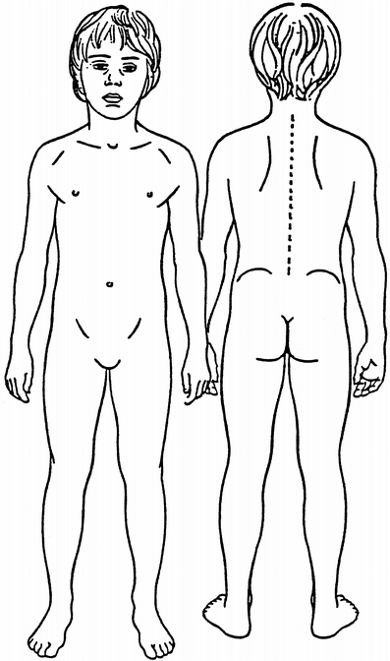
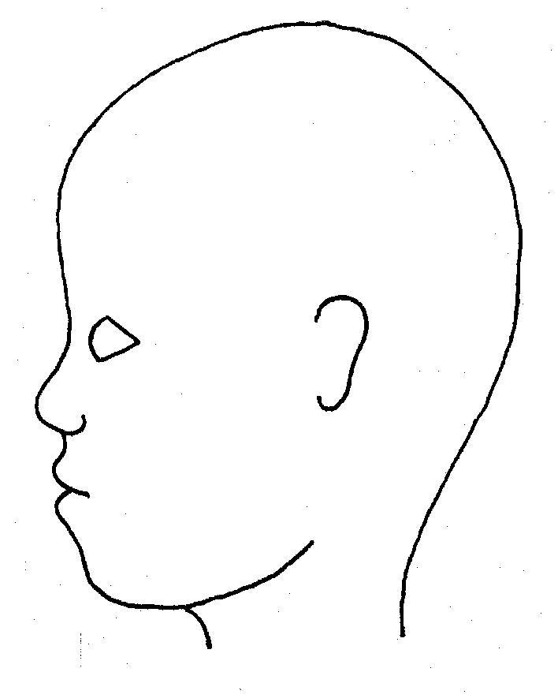
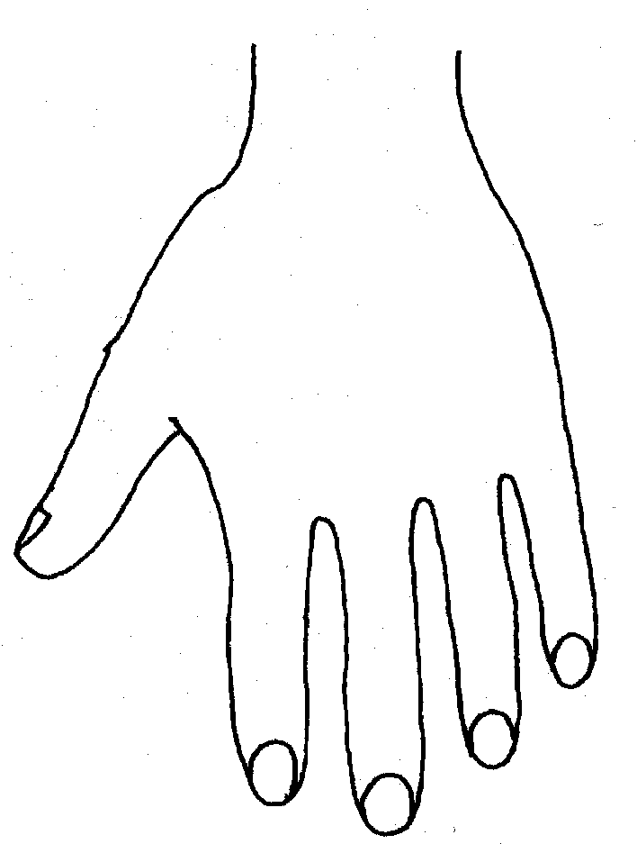
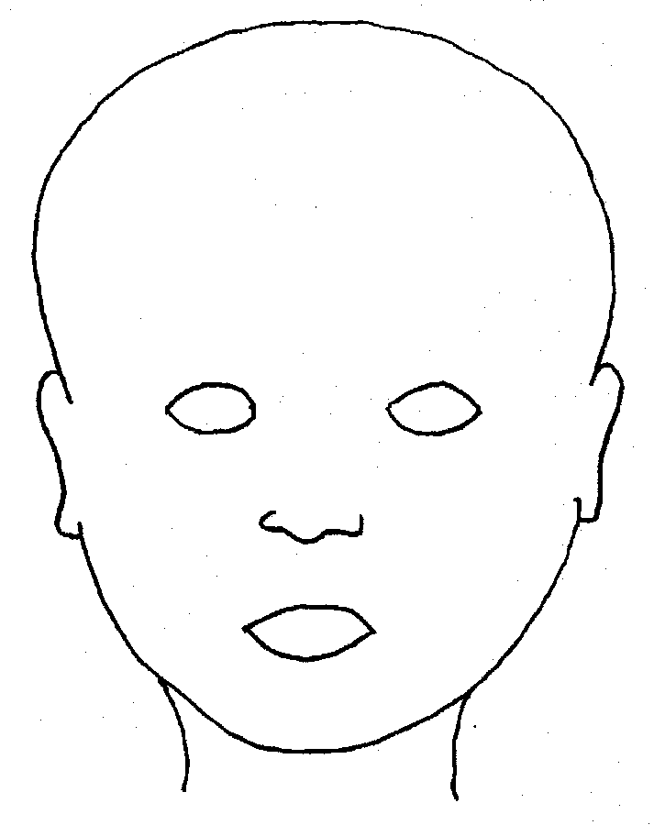

Concern Form Part B
To be completed by the school’s Designated Safeguarding Lead (D/DDSL)

Child’s status with Early Help or Children’s Social Care (please tick & add name where known)
at time of initial report
None | CAF |  | Known to Social Care | Allocated social worker | Child Protection Plan
Name of allocated worker
Name of D/DSL reviewing the concern
Name of person taking action |  | Action |  |  |  | Date
Feedback given to person who raised the concern? |  |  | Y / N
Name |  | Date

Appendix 4-

Flow Charts for –

Allegations against School Staff.

What to do if you are concerned a child is being abused.

are posted in the staff room, the office and in all staff toilets.

