

**Anti-bullying week at Dilton School**

This week is anti-bullying week, and in our house teams we have been making non bullying charter to keep our teams in shape. It’s quite good fun making a Reith of hands and writing a thoughtful message to put in the middle, maybe you can have a go to?

By Jay Kinzett

11th Edition – 14th November edition

By children, for children.

DILTON TIMES



**Times Table Rock stars is an instant hit!**

Times tables rock stars is an amazing maths game that our school love. It is a fun competing and quick fire game that is so fun. You have to answer as many times tables questions as you can in 1 minute. Our teachers in Oak, Beech and Chestnut have set up a battle of the bands. Our classes can now compete against each other. Our school love it and we would like you to encourage your child to do it at home. So, keep multiplying!

By Jay Kinzett and Rebekah Slarke

**Amazing drone footage of Iceland taken!**

Iceland is a pretty small country, but that doesn’t stop it from having INCREDIBLE features, like geysers, volcanos and hot springs.

But a drone managed to capture AMAZING images of the Northern Lights in Iceland’s night sky. The images really are great!

By Wilf Hewitt-Grainger

**Christmas homework**

For our Christmas homework this year we have been asked to design front cover for the fayre program. If you don’t know what the front cover program is it’s the little booklet you get on your way in to school. One person is going to have their picture on the front cover, and the next piece of homework is making a Christmas decoration for our four Christmas trees.

By Charlie Oley

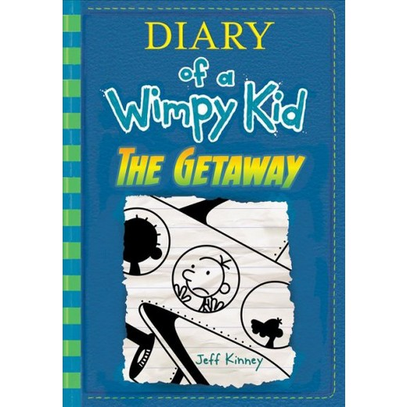

# **The Getaway by Jeff Kinney**

Hey, guys! This week, get ready to peek into the life of a middle-schooler, Greg Heffley, on a catastrophic holiday that essentially resembles a Christmas formed out of a NIGHTMARE. The Getaway is the latest instalment of the series “Diary Of A Wimpy Kid” and is written by an American writer, Jeff Kinney. The story is as follows…

The Heffleys accidentally begin to put up their Christmas décor late, which leads to a fight between Greg’s Mum and Dad. The next day, over dinner, Mum and Dad announce that they will be going to the resort where they spent their honeymoon, instead of the cold weather and CHRISTMAS PRESENTS! Greg tries to get Rodrick and Manny (his two brothers) to help him persuade them not to go, but they end up going, and this holiday surely will turn out to be one the Heffleys will never forget.

By Ruby Yates

**Panda loving the snow**

Pandas in a zoo at the North East of China are making the most of their snowy weather this winter. They have been in some nonstop snow settling all over their lovely town of Yabuli. These giant stripy pandas have been rolling, jumping and having fun!

In their cage of bamboo and wood, the pandas have been playing to their hearts content in their lucky streak of snow. Since the snow started, the pandas have not wanted to play on their playset, instead dancing in their frosty enclosure of fun.

By Caroline South

**An interview with Ruby Cooper (Cherry class)**

Q: What’s your favourite Christian value?

A: Kindness/friendship

Q: What’s your favourite book?

A: Topsy and Tim go camping in a caravan.

Q: What’s your favourite lesson?

A: Science

Q: What’s your favourite TV programme?

A: Ben and Holly

Q: What’s your favourite food?

A: Cheese and Onion Pie

Q: What’s your favourite animal?

A: Reindeer

Q: What’s your favourite colour?

A: Green

By Oscar Froggatt and Shannon Pierce