

**Newspaper club hailed by SIAMS!**

The newspaper club has been mentioned in the SIAMS report which we got an OUTSTANDING! We are Neil revels first ever school to get an outstanding in his career. The inspector commented, “Children produce the weekly ‘Dilton Times – by children, for children’ newspaper which includes articles and children’s insights about world news. Taken together these all foster an exceptionally strong sense of community cohesion which was a focus for development in the previous inspection.” In Newspaper club, we are proud that we have been recognised. Well done Dilton marsh!

By Jay Kinzett

10th Edition – 7th November edition

By children, for children.

DILTON TIMES

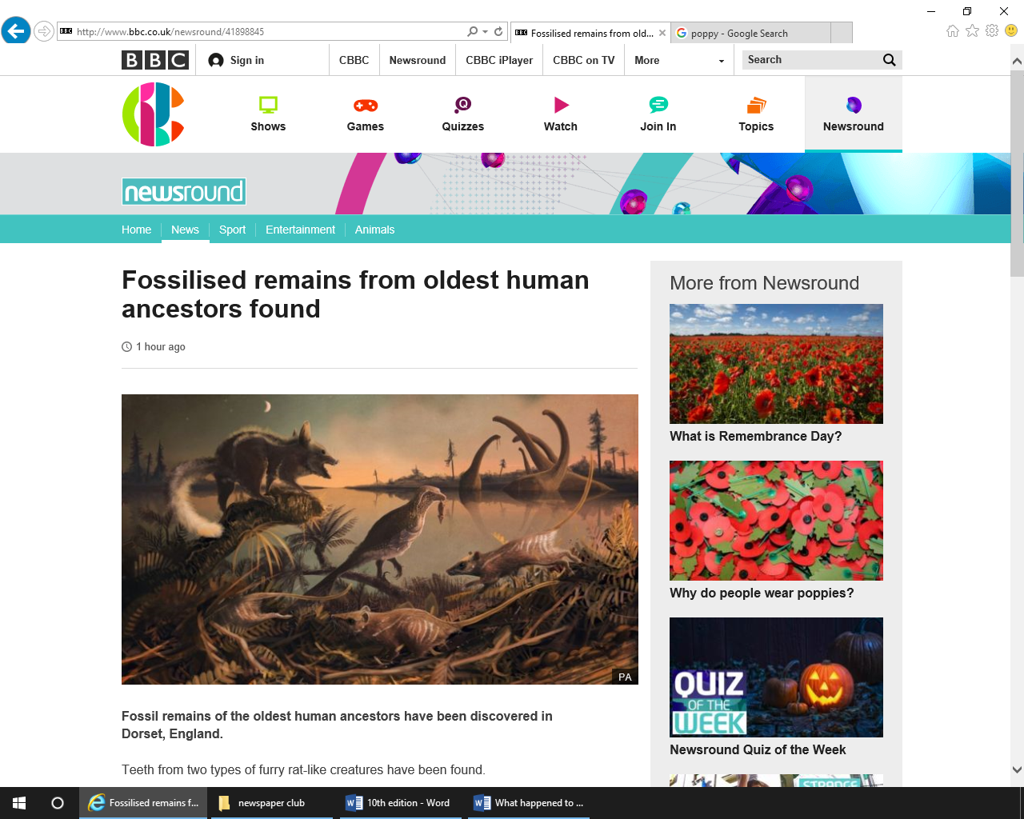

**Why do people wear poppies?**

People wear poppies because it represents people who died in the war. The red represents the blood of the soldiers and the black represents the lives lost. On Sunday Tom and Poppy represented our school at Dilton Marsh memorial, they were great ambassadors.

By Oscar Froggatt

**What happened to girls and their liking of sports?**

Girls may find sports too competitive and dislike how they’re taught P.E. The students think it is too competitive, sweaty or that they just don’t like sports. The surveyors think the girls should have an opportunity to do activities like dancing or roller skating, for example.

To fix this, the surveyors think schools should start celebrating taking part as much as winning. Hopefully, more girls will love sport and P.E. in the future.

By Caroline South

By Caroline South

**Fossilised teeth**

Recently some fossilised teeth were found in Dorset from a pair of rodents. Both are different species one smaller than the other one the small one is thought to eat insects and the other ate plants as well.

By Wilf HG

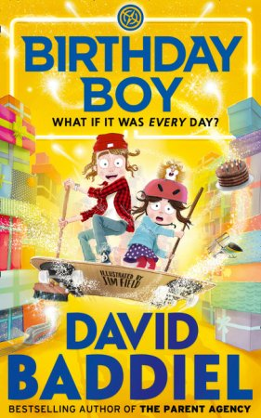

**Paddington 2**

Have you watched Paddington? Then you’ll love Paddington 2! The first Paddington was made in 2014 and Paddington 2 is the Christmas treat for 2017. Paul king is the director of Paddington. The story focuses on the unspeakable Phoenix steals a pop-up book from Mr Gruber’s shop: a book which contains coded clues to where a fabulous cache of treasure may be found – and he frames Paddington for the crime. So poor Paddington goes to prison for something he did not do but there finds friendship. Catch the film in cinemas this Christmas!

By Amelia Fairhurst

**An interview with Miss Dando**

Q: What is your favourite colour?

A: Purple

Q: If you were in a house, which house would you be in?

A: Merlin

Q: What is your favourite lesson to teach?

A: Maths

Q: What do you like to do in your spare time?

A: I like to go on long dog walks also I like to go to the gym

Q: Do you like this school?

A: Yes I enjoy being here

By Charlie Oley and Rebekah Slarke

By Rebekah Slarke and Charlie Oley

**Strictly come Dancing!**

Strictly is an enjoyable programme on BBC that lots of people love. And everyone was surprised when Debbie McGee’s tango got 4 tens! The amazing star performed with Giovanni and Craig Revel Horwood got off his chair and bowed down to her!

By Shannon Pierce

# **The Person Controller and Birthday Boy Book reviews!**

Hello, book fans! This week we’ve got a double extravaganza of two books from the same author- David Baddiel- and these are my favourites!

First up, we have The Person Controller. It’s about two twins, Fred and Ellie, who are “nerds” and are amazing video-gamers (even if Fred prefers customising the avatars). One day, after a run-in with the school bullies, Isla and Morris, they accidentally place an order for a controller that controls people. After the box arrives after school, Fred puts on a bracelet that was included in the pack. Once Ellie starts fiddling around with it, Fred starts leaping high, owning the bullies in battle and ultimately passes the football trial. It seems like it can solve all of their problems… but sometimes even the greatest things must end.

The next one is called Birthday Boy and is a new release. A boy called Sam wishes on a shooting star at the end of his 11th birthday, and his birthday starts happening again and again and again, day after day. But when Grandpa Sam goes missing and everybody doesn’t help, Sam has to find a way to un-wish his wish.

By Ruby Yates