The Dilton Dozen Reading List – Year 1 & 2

Summer Term

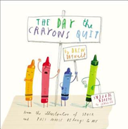
The Day the Crayons Quit by Oliver Jefferies

Duncan just wants to do some colouring - but when he opens his box of crayons, he finds a whole bundle of letters of complaint. The crayons aren't happy: Beige is sick and tired of playing second fiddle to Brown; Blue is exhausted after colouring in so many oceans, lakes and rivers; Orange and Yellow can't agree on who is really the colour of the sun; and Peach has a rather embarrassing problem. Can Duncan come up with a solution to keep the crayons happy - before they quit colouring for good?

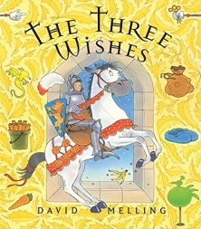
The Three Wishes by David Melling

The hapless knight and his faithful horse are left to babysit the prince and princess. But babysitting is a lot harder than they think. Add to the mix - a bag of spells, a little magic and three wishes - and it's going to be a long night. From the bestselling creator of Hugless Douglas, this delightful story is full of humour, charm and magic.

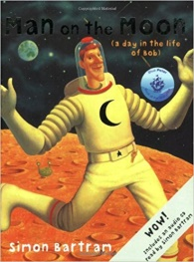
Man on the Moon by Simon Bartram

Looks at a day in the life of Bob. Find out what he does on the moon: cleaning and tidying, welcoming visitors, performing tricks for tourists and much more. He knows almost everything there is to know about the moon - but there's something going on behind his back that he hasn't spotted.

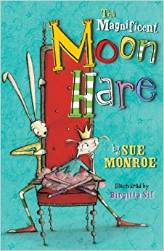
The Magnificent Moon Hare by Sue Monroe

This is Roald Dahl meets Alice in Wonderland in a quirky, laugh-out-loud story for boys and girls. Packed with dragons, princesses and a whole host of hysterical characters, it's also perfect for reading aloud. It's a book that will sweep you off into an adventure full of daring rescues, narrow escapes and liquorice allsorts. Quite simply don't miss it.

Muncle Trogg by Janet Foxley

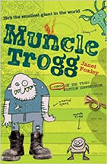
Muncle Trogg is the charming upside down fairytale about a tiny giant who saves the day. It's a debut novel and the first in a series of adventures featuring Muncle, the smallest giant in the world.

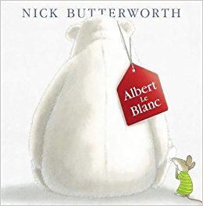
Albert Le Blanc by Nick Butterworth

An uplifting story about a bear without a smile from the bestselling creator of Percy the Park Keeper. When Albert le Blanc arrives in Mr Jolly's toy shop, the other toys think he's the saddest-looking bear they have ever seen. They decide to put on a show to cheer him up. Albert tries to tell them he's not sad, he just looks sad, but they are all too busy making preparations...As a finale, Sally the hippo puts on a lipstick and performs ballet, but she falls on top of Albert and leaves a huge lipstick grin on his face. Everyone laughs...especially Albert!

Sir Charlie Stinky Socks and the Really Big Adventure by Kristina Stephenson

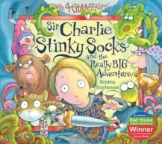
Charlie is big, bold and daring but is he brave enough to rescue a damsel in distress? Find out by joining him on a really big and frightening adventure. Vibrant illustrations and fold-out flaps give the story an additional dimension that can’t fail to entrance the reader and bring them back time and time again.

The Disgusting Sandwich by Gareth Edwards

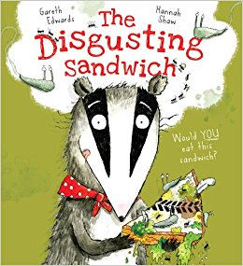
There’s a great joke running right through this witty picture book to the excellent punch line. Badger is always hungry and now his tummy is rumbling! He so badly wants the fresh white bread and peanut butter sandwich which he sees in the little boy’s hand. But others have designs on it too…A squirrel, a fox; a frog and a crow are just some of those who also covet the sandwich. After several accidents in which it gets gloopy, squishy, sluggy and slimy the sandwich does not look as good as it once did. Will anyone eat it now?? A hilarious treat of disgustingness!

Tidy by Emily Gravett

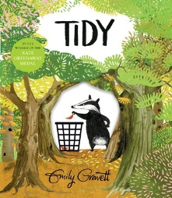
Pete the badger likes everything in the forest to be neat and tidy. He snips off flowers that don’t match, washes the birds, vacuums the forest floor and sweeps, scrubs and polishes until everything is spick and span. As the autumn leaves fall, he swiftly scoops them up into a mountain of refuse bags. Then, deciding the bare trees look unsightly, he digs them up! When his overzealous tidying begins to have a damaging impact on the forest Pete realises he may have gone too far. Will he be able to rescue the forest?

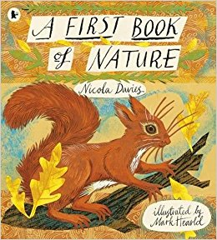
A First Book of Nature by Nicola Davies

A lovely chronicle of a child’s first experiences with nature. Beautifully illustrated. Part of the book is poetry, part scrapbook of recipes and facts. It is a delightful way to learn about the natural world. It is also full of ideas for fun outdoor activities.

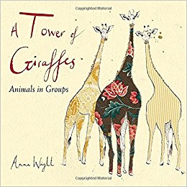
A Tower of Giraffes by Anna Wright

A magnificent picture book presents an assortment of birds and animals, each grouped under their collective name and accompanied by entertaining factual snippets. Learn about the social habits of the fittingly-named Prickle of Hedgehogs and Tower of Giraffes.

The Unlikely Outlaws by Philip Ardagh

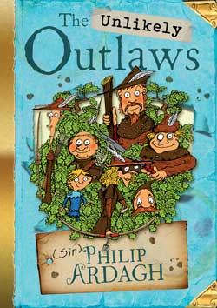
Three cracking comic adventures about the Green Men of Gressingham, a rum bunch of outlaws living in the forest all dressed in … brown (because it hides the dirt better), under the leadership of the mysterious, glamourous Robyn-in-the-Hat.

