The Very Hungry Caterpillar By Eric Carle  A perfect introduction to the life cycle of a caterpillar. With cut out pages with finger sized holes, this is a perfect book and one of Mrs Farndale’s favourite children’s books  Gracie Grabbit and the Tiger By Helen Stephens  Gracie Grabbit is going to the zoo with her dad, but she has one problem – her dad’s a cheeky robber! She needs to stop him spoiling her day, but how? Luckily, a friendly tiger is on hand to help out – with lots of fun mix ups along the way.  Oi Dog! By Kes Gray, Claire Gray  Frog has had enough and he is changing the status quo! cat insists that there are rules – only mules can sit on stools, no one but hares should sit on chairs and however irritating, dogs MUST sit on frogs! Frog is changing the rules though! And everyone else is going to have to sit somewhere else too!  Grandad's Island By Benji Davies  Syd and Grandad’s tropical adventure tells a much bigger story and conveys an important message about loss and love.  The School Trip By Nick Butterworth  Are you ready for the school trip? There will be dinosaur bones and giant blue whales, buttons to press, lunches to swap and money to spend. The coach is waiting to go. But where is Matthew Tibbs? | 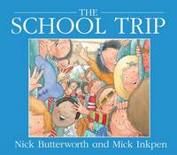  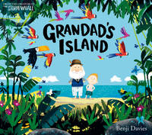  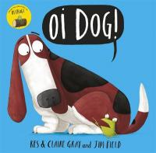  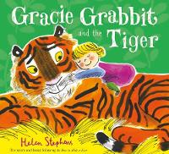  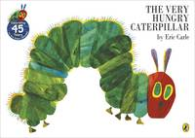
Kipper’s Birthday By Mick Inkpen
The day before Kipper’s birthday he prepares his party invitations and makes a cake. He invites everyone to his party tomorrow, but doesn’t deliver the invitations until the next day. Hence all sorts of confusion. When exactly is my birthday, wonders Kipper.
Tiddler By Julia Donaldson  Tiddler is a fish that tells the tallest tales in the ocean, so who will believe him when he really gets caught in a net? | 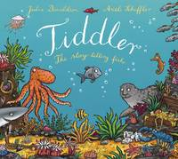
There's a Tiger in the Garden By Lizzy Stewart Grandma’s back garden turns into a jungle full of adventure in this striking picture book. Nora is bored, so her Grandma suggests she play in the garden, there might, she says, be a tiger there.  The Snail and the Whale By Julia Donaldson  “How Long to sail? said the tiny snail. One little snail longs to see the world and hitches a lift on the tail of an enormous whale. Together they go on an amazing journey, past icebergs and volcanoes, sharks and penguins.  Grandad's Secret Giant By David Litchfield  This is a giant story of belonging and friendship. he has hands the size of tables, Grandad said, legs as long as drainpipe and feet as…  Pirate Pete and His Smelly Feet By Lucy Rowland Poor Pirate Pete’s feet are so stinky that his crew are finally driven to chuck him overboard. They happily take him back though when his pongy feet turn out to be an effective shark repellent.  Hug Me, Please! By Przemyslaw Wechterowicz  Daddy Bear and Little Bear are enjoying a day in the forest and after a sweet snack of honey Little Bear suggests they give Mr Beaver a hug, to liven up his day. Increasing the amount of hugs given and received can only make the world a better place. | 