The Dilton Dozen Reading List – Year 5 & 6
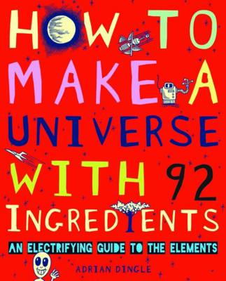
Summer Term
How to Make a Universe from 92 Ingredients by Adrian Dingle
A unique and imaginative take on chemistry, with “experiments” that show how all things are made from just 92 chemical elements.

Simon Thorn and the Wolf's Den by Aimee Carter
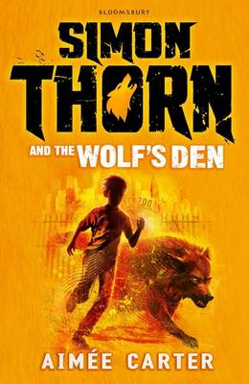
Like Harry Potter, Aimée Carter’s twisty, original thriller stars a gang of kids with special abilities up against a cast of powerful adults, some of whom are decidedly untrustworthy. Instead of being trainee wizards however, these young people are at shapeshifter school learning to turn themselves into animals. Simon can talk to animals, but had no idea he could be the heir to a shapeshifting dynasty until suddenly he’s at the centre of a decades-old intrigue, with a new set of friends, and even a brother he never knew he had.
A Girl Called Owl By Amy Wilson
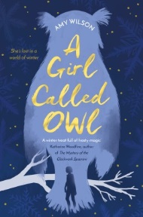
Thirteen-year-old Owl has never met her father, and her mum won't tell her who he is. But when Owl starts to find strange frost patterns on her skin, she is determined to find him. Through a strange new boy at her school named Alberic, she begins to learn that the fairy tales and magical world her mother told her about are real - and that her father is actually Jack Frost. Owl soon finds herself in a cross between the human and fairy worlds, where her very existence isn't welcome, even by her own father.

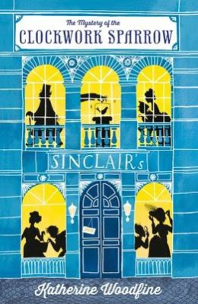
Mystery of the Clockwork Sparrow by Katherine Woodfine
Enter a world of bonbons, hats, perfumes and mysteries around every corner. Wonder at the daring theft of the priceless clockwork sparrow! Tremble as the most dastardly criminals in London enact their wicked plans! Gasp as our bold heroines, Miss Sophie Taylor and Miss Lilian Rose, crack codes, devour iced buns and vow to bring the villians to justice… Discovering Sinclair's Department Store, the setting of the mystery and where much of the book takes place, is a treat and the descriptions make the reader feel as if they are really there- 'It smelled luscious…a glorious fragrance of cocoa and candied violets and some other spicy scent.'

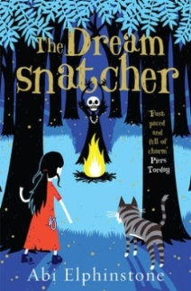
The Dreamsnatcher by Abi Elphinstone
Moll Pecksniff, a gypsy orphan living in the Tanglefern Forest with her wildcat Gryff, is haunted by a recurring nightmare that pulls her from the safety of her caravan and deep into the forest. Lured by the beating of an unseen drum, she awakens one night to find her terrible dream has become reality. She has been summoned by the Shadowmasks: a group of magicians who plan to kill her - as it has been foretold that Moll is the only one who can save the Old Magic and stop the Shadowmasks taking over. With help from Alfie, a mysterious boy from the enemy camp, Moll and Gryff must fight the darkness to fulfil the Bone Murmur prophecy.
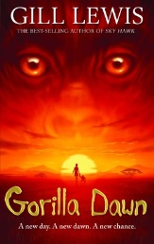
Gorilla Dawn - by Gill Lewis

This is the story of Imara, taken as a small child from her village when rebels raid it, and brainwashed into thinking that she has magical powers. A parallel theme relates Bobo's experience, determined to discover the truth when his father, a National Park ranger, vanishes during a rebel raid to collect young gorillas for sale.

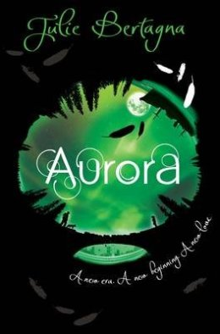
Aurora by Julie Bertagna
The third in a series which portrays a future world devastated by global warming, Aurora introduces us to the headstrong Lily, Mara's daughter, who sets out in search of Fox, her birth father, and in doing so, discovers lands and peoples they had thought completely destroyed. Bertagna's writing is lyrical and poetic, and this sometimes violent fantasy holds particular power for its examination of family, love, loyalty and friendship even in adversity.
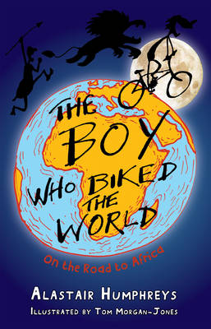
The boy who biked the world by Alastair Humphreys
Tom really wants to be an explorer. When Tom’s head isn’t in the clouds it’s in an atlas. He follows adventurers not footballers and his school days are spent dreaming about traveling from Tibet to Timbuktu. One day a private wish was blurted out loud started his freewheeling adventure. Ride along as Tom overcomes his fears and sets off on the first part of his biggest ever adventure.

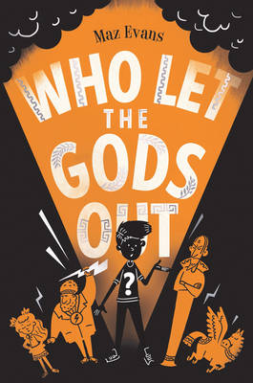
Who Let the Gods Out? by Maz Evans
Who Let The Gods Out is a super, funny adventure story that will have kids reading long past their bedtime. Poor Elliot is having a very tough time. His mum is poorly, they have serious money problems, a devilishly devious interfering neighbour and school is quite simply a complete nightmare! So the last thing Elliot needs is for a conceited constellation to crash land smack, bang in the middle of his cow shed. Suddenly feisty, fearless Virgo enters his life with ‘a damp, loud splat.’ Together they manage to set free a dangerous and incredibly evil Daemon of Death and before long it is down to Elliot to save the world.

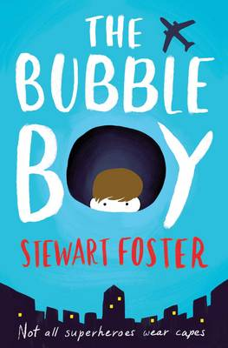
The Bubble Boy by Stewart Foster
Deeply moving and utterly gripping, Bubble Boy is a stunning novel that makes you laugh and cry. And think. Joe lives in a sterile world. Wired up to monitors and drips, he can’t remember ever having left his hospital room. Even his visitors are a potential risk in case they bring in infections. Everyone cares for Joe by keeping him as enclosed as it is possible to be. But then he has a visitor who has a quite different view of what Joe’s life should be like. Suddenly Joe’s world is full of information about the world outside and his dreams of going out grow bigger and bigger. Can Joe ever fulfil his dream?

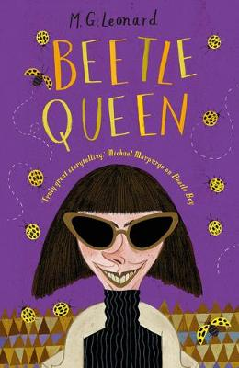
Beetle Queen by M.G.Leonard
Lucretia Cutter is back, undoubtedly one of the creepiest (crawliest) villains in children’s fiction, and she’s up to no good again. Ranged against her are our hero Darkus and his friends Virginia and Bertolt, together with their special allies – bugs, beetles and assorted insects. The plot scoots along like a spider on a tiled floor, the dialogue crackles and the cast of characters features an array of the weird and wonderful. Irresistible reading and it will make you see the insect world in a whole new light.

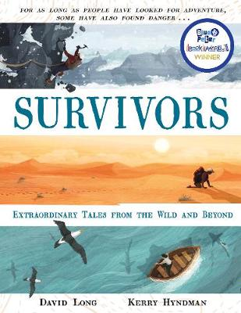
Survivors by David Long
In a nutshell: jaw-dropping true stories; survival against the odds. Proof that true stories can be every bit as remarkable as the most fantastic fiction, David Long recounts twenty plus astonishing true life adventures; from different times, starring different types of people, and set in different parts of the world, they are all stories of incredible bravery, resilience and the strength of the human spirit. Both terrifying and inspiring, the stories make compulsive reading and will leave young readers gasping.

