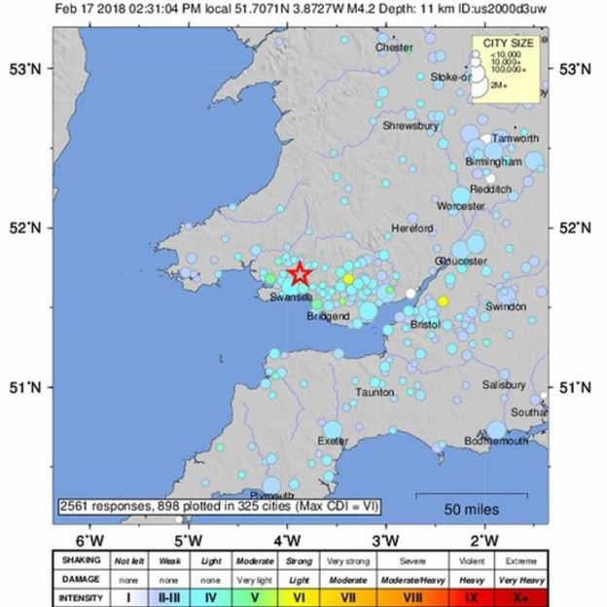

18th Edition – 20th February 2018

**Welcome to KFC – Your Kentucky Fried CHAOS coming up!**

Over half the United Kingdom’s KFC restaurants have had to close due to delivery problems. This resulted in KFC switching their company for delivering their chicken.

Kentucky Fried Chicken originated in America and has been served up as a popular food in the UK.

Though you might not be impressed, they have to do it or KFC will be in the bin.

By Caroline South and Harry Lawrence

By children, for children.

DILTON TIMES



**Winter Olympics 2018**

Lizzy Yarnold wins gold AGAIN in skeleton! Lizzy Yarnold shows great courage in the skeleton. She had a chest infection before performing, but because of helpful comments from her doctor, she pulled through and came to win yet another gold. Her teammate, Laura Deas, also brought home the bronze. Well done, girls- amazing results!

By Oscar Froggatt and Lauren Cooke

**Earthquake ahoy!**

On Saturday, a small earthquake shook parts of Wales and England. The earthquake only had a magnitude of 4.4 which meant there was no damage and nobody got hurt, the ground only shook very gently. However it could have broken down walls!

The epicentre of the earthquake, which is where it started was around 20m from Swansea in Wales. Earthquakes of this size are not often felt in the UK and it is very rare.

It started to shake in Swansea, then it was felt in Bath and then Westbury. Nobody really felt it but it definitely shook.

Did you feel it? We did!

By Theo Baalham and Kian Pierce

**Disney Quiz**

Testing your Disney knowledge…

1. From the film Cinderella, what are the names of the two ugly step sisters?
2. Which Disney film was made first? HINT: It’s one of the Disney princesses and she gets poisoned by an evil queen!
3. Which Disney princess kisses a frog?
4. What are the names of the seven dwarfs?
5. In the film Tangled at the start there are twins and Flynn Rider, but what are the names of the twins?
6. In sleeping beauty what are the names of the three fairies?
7. Which fairy in Tinkerbell is the garden fairy?

**Submit your answers to Miss Tout by Friday!**

By Madison Hibberd

# **Film review of Early Man**

Who knew cavemen invented football?

Join Dug, his boar, Hobnob, and the skilled Gooma as they train to beat the crude, rich, powerful and INTELLIGENT Bronze Agers. If they win a football game against them, their home is theirs once more.

But, can they actually successfully win when the Bronze Agers are such All-Star winners…?

Find out today, film fans!

I would rate this 5 stars. If I could rate it higher, it would be 100!

By Ruby Yates



**The Roman Mysteries Book Review**

This chronicles has at least X (10) books the first of which is called the thieves of Ostia it is based in Rome in Italy and has IV (4) main characters Flavia Gemina a high born Roman girl, Jonathan Ben Morcidi a Jew living next door, Lupus a beggar boy with his tongue cut out and Nubia Flavia’s slave girl. I would recommend it for people aged 9-11.

By Wilf HG

**Dilton Fundraising**

On Friday 20th April 2018 we are holding a fundraiser after school from 3pm till 4pm. The event will take place in the school hall. Any donations of books and/or cakes will greatly appreciated. The theme will be Alice in wonderland. Tea, coffee and cakes will be served whilst you can peruse tables of books. The books will be separated into categories including ks1, ks2 and adults. We hope you can make it! ☺

By Rebekah Slarke and Evie Lawrence

**An interview with… Mrs Hyde**

Q: what’s your favourite T.V show?

A: Dancing on ice/ strictly come dancing

Q: What’s your favourite pudding?

A: Lemon cheesecake

Q: What’s your favourite ice cream flavour?

A: chocolate

Q: What’s your favourite colour?

A: Purple

Q: What’s your favourite shape?

A: Circle

Q: What’s your favourite animal?

A: Dog

Q: What’s your favourite number

A: 17

By Charlie Oley and Amy Cooper