

13th Edition – 5th December 2017

**Santa hit the ski slopes!**

TheSundayRiver resort in Maine in the United States hosted a special Christmas charity event this week.

The day, “Santa Sunday”, was a charity event where people dressed as Santa and snowboarded/skied down winter’s snow blanketed hills. Adults and children all put on their best Santa Claus impressions.

Not only did adults go dressed as Santa, but used candy canes as ski poles and candy textured snowboards!

Have a wonderful time this Christmas people.

Ho, ho, ho!

By Caroline South

By children, for children.

DILTON TIMES

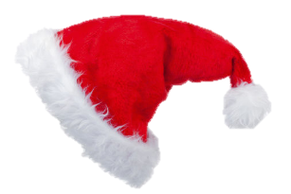

**Rak Su Wins the X Factor!**

Breaking news, Rak-su are the first boy band to win the x-factor. I haven’t watched it but if you have you will know. I have also herd they are quite good so good for them! If you haven’t, like me, you can find it on catch-up on a TV near you. ‘Dimelo’ is the winning song they used which is supposed to be awesome. Or so a friend of mine has told me, so go Rak-su!

By Jay Kinzett

**Santa Paws film review**

The search for Santa paws is a great film all about Santa’s dog. His friend had recently died and had given him a toy dog that only came alive if you believed it could. Then, one night, when Santa is delivering presents, he trips over and loses the crystal that makes him remember everything! Santa Paws runs away and is found by a orphan girl who takes him in and everyone adores him! Until their social worker takes the beautiful crystal from around his neck. Will Santa start to remember again and save Santa paws from becoming a toy forever...?

By Rebecca Slarke

**Rebekah’s Did you know…**

Nelson Rolihlahla Mandela sadly died on this day four years ago!

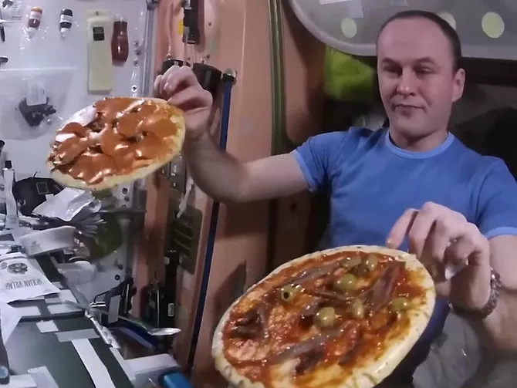

**This is our last newspaper of 2017!**

**Pandas**

Pandas do yoga when they are bored! Yes you got that right! There is one panda, called Fafa, and he is the only one in his pen so plays on his own. Fafa lives at the Liaoning Shenyang Forest in China. Fafa is the only male panda in the zoo. To keep himself entertained, the mischievous panda has mastered quite a few tricks such as: playing with a ball and some yoga.

By Wilf HG and Charlie Oley

**Pizza Party**

Do you enjoy space and pizza? Well guess what? The first ever pizza party has been held in space. It is all thanks to Italian astronaut Paolo Nespoli. After making the pizza, the six astronauts tossed and twirled them like floating Frisbees or as  commander Randy Bresnik described them 'flying saucers of the edible kind’. Paolo Nespoli mentioned that he really missed his favourite food pizza so NASA decided to send up the ingredients. “Houston I think we’ll have pepperoni!”

By Amelia Fairhurst

# **How to Train your Dragon Book Review**

Take a trip to the little isle of Berk with Hiccup, the skinny (yet smart) heir to his tribe and Fishlegs, the only Viking alive with asthma and a squint! In this book, the first in an exciting series, Hiccup and his friend, Fishlegs, must catch their dragon and train it to pass the initiation test and enter their tribe as aspiring heroes. But when you’ve got the best boy in the class, Snotlout, and his sidekick, Dogsbreath, after you, a simple test can turn into a nightmare. It becomes even worse when Hiccup and the class fail the test and are banished… but must help the tribe defeat a MASSIVE BEAST. Can they do it?

By Ruby Yates

**An interview with Miss Ronxin**

Q: What your favourite thing you’ve learnt about Dilton?

A: Children are friendly and welcoming

Q: Primary or secondary?

A: At this rate, primary

Q: IT or English?

A: Neither, Maths!

Q: What’s your favourite animal?

A: Dog

Q: What would you be if your weren’t a teacher?

A: Rich!

By Oscar Froggatt and Shannon Pierce