

**Storm Eleanor**

From Monday 1st January its been very windy. Power cuts and road closures aren’t the only thing people had to deal with. Across the UK there have been flying trampolines making some unusual journeys. Some trampolines flew to other peoples back gardens, the train tracks near Aylesbury, there was one wedged between a local shop and a bus stop! But that’s not it! Storm Eleanor brought 70-100mph gusts of wind and loads of heavy rain! Lots of people lost belongings-one victim Miss Tout reported “I lost my bin and it cost £75 for it- a waste of money!”

By Caroline South and Madison Hibberd

14th Edition – 9th January 2017

By children, for children.

DILTON TIMES



**What can you see?**

**Caroline’s mathematical fact…**

Spiders have 48 knees. So how many knees in each leg?

**Big Ben’s lost its chime**

Big Ben- it’s iconic, isn’t it, with its loud chimes ringing out over London.

Well, there are plans to stop it chiming until 2021 for it to go under maintenance. Strangely, however, the clock will still ring out for New Year’s Eve, so it’s not all bad. As it’s 2018 now, we can only hear the clock 2 more times- until it will ring in New Year’s Eve at the end of 2020, when 2021 finally comes and the clock resumes its position in London!

By Wilf HG and Lauren Cooke

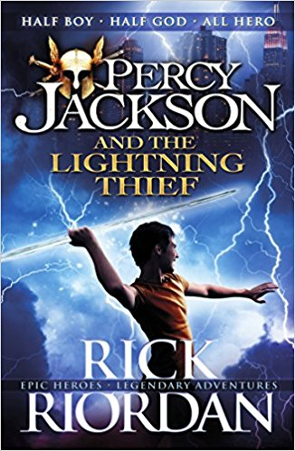

# **Percy Jackson and the Lightning Thief Book Review**

Percy thinks he’s just an ordinary kid in 6th grade- but that IS before he accidentally vaporises his demon maths teacher. After being expelled from Yancy Academy and travelling back to Manhattan with Grover, his friend, his mom promises a relaxing beach getaway. But when they have to flee from a minotaur and Percy loses his mom, he collapses near a pine tree- and things get better from there, thankfully. Percy discovers he is a Demi-God- Half mortal, half god- and can control water like his father, Poseidon. When Percy, Annabeth (The daughter of Athena, Goddess Of Wisdom) and Grover venture out to return a stolen lightning bolt- Zeus’ bolt, who is also Percy’s uncle- they have to prepare for a perilous journey. I mean, Homework Or Fighting Monsters?! Tough choice…

By Ruby Yates

**Litter**

Has been gathering in the playground

and it is not a laughing matter! If you see litter in the playground, please pick it up. It will help a lot because it is killing animals.

Big or small? 4 or 11? whoever you are. SAVE OUR SCHOOL ENVIRONMENT!

**Did you know?**

Chestnut Class have found over 50 pieces of litter in the playground!

Just think how many pieces of litter that is in the whole world.

By Kian Pierce and Theo Baalham

**Madison’s Did you know…**

Cats have 32 muscles in each ear!

**The World’s smallest cat**

The cats live in Sri Lanka and don’t weigh much more than a bag of sugar. They can almost sit in the palm of your hand, and are 200 TIMES SMALLER than a lion!

The strangest thing is that this is them when they are FULLY GROWN!

By Oscar Froggatt and Sophie Geary