

**You though pirates were made up? Think again…**

HAPPY INTERNATIONAL TALK LIKE A PIRATE DAY!

You have probably seen films of pirates but are fictional. Well, think again. Pirates did actually exist and are still alive today! Their golden days were between 1680 and 1730. In those days, they were called swashbuckling pirates.

They were a problem for the navy fleets and caused chaos for the seas. Today they are called modern day pirates. Everyone is quite scared of old time pirates. I would. Would you?

By Rebekah Slarke and Jay Kinzett

Sixth edition – 19th September 2017

By children, for children.

DILTON TIMES

**What’s lurking in this loft?**

If you were to ask someone to list everything they have in their attic they probably couldn’t manage it .In fact , poking around in a loft doesn’t normally reveal about ten million bees that’s for sure.

By Oscar Froggatt

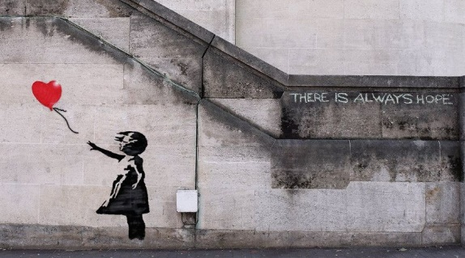

**Who is Banksy?**

Banksy is a famous street artist but anonyms he keeps his identification to himself. He began spray-paintings in the early 1990s but in 2000s he expanded his work beyond Bristol.

By Amelia Fairhurst

**The Invictus games**

The invites Games where invented by Prince Harry so injured

Soldiers to compete in Radom challenges. Lots of solders

Get injured in the war so the Invicta Games was made.

The first ever invites games open in London this event will be held in some of the venues used during the Olympics.

By Freya Hodgkinson-Rowe and Amelia Fairhurst

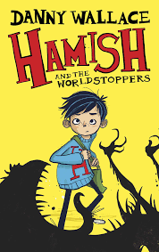

**Toe-tally weird wrestling!**

Every year in Derbyshire there is a toe wrestling competition where people wrestle only using their feet! The championships have been going on annually since the 1970s and still just as popular. Allan Nash is the current champion for the 14th time running!

By Wilf HG

**The £99 Ice cream!**

In Norway people eat a lot of ice cream because they love it so much.

The £99 ice cream looks delicious it has a macaron a chocolate spoon also a flake. This ice cream must be very nice!

By Charlie Oley

**Hamish and the Worldstoppers review**

Written by Danny Wallace, this book is the first in a 3 part series.

The book is about a young boy called Hamish who lives in the most boring town ever- Starkley. But one day, in class, the world completely freezes- but Hamish is the only one still moving around!

After discovering this is due to a filling formula, Hamish and his friends (Elliot, Alice, Buster, Venk and Violet) must find a way to save the world…

Who knew a boring town had such an awesome secret?

This book is super cool, and I think children from ages 6-11 would enjoy Hamish the most.

By Ruby Yates

By Ruby Yates

**An interview with Mr Foyle**

Q: What would you be if you were not a teacher?

A: Professional footballer, barber or police officer.

Q: What is your favourite part about Beech?

A: They are all welcoming and kind

Q: What’s your favourite colour?

A: Black and grey

Q: What is your fav subject to teach?

A: English

Q: If you weren’t in hawk what house would you be in?

A:Merlin same colour as Liverpool

By Shannon Pierce