**Beech Class - Year 5 - Terms 3 & 4 - 2017**

**Science**

The focus for Science will be the forces and how forces impact on everyday life. The children will experiment with air resistance, and water resistance in relation to parachutes and submarines.

**Maths**

Maths learning during these terms will continue to focus on:

Place Value, Calculation,

Fractions, Decimals and Percentages,

Geometry, and Measurements.

**Religious Education**

Due to a change in plan (last term during which the children learnt about Hinduism) the children will now be finding out about the Sikh faith. Children will also consider Easter and its importance to Christians.

**English**

We will be looking at a wide variety of texts linked to World War Two. We will look at diaries, personal letters, and poetry. Aspects of the Year 5 spelling, grammar and punctuation programme will continue to be explored.

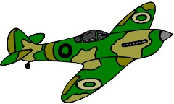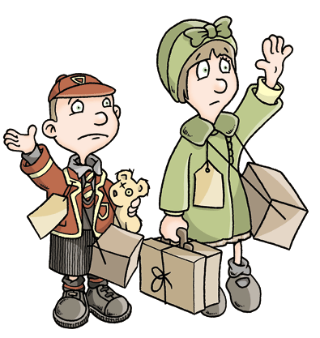

**World War Two**

**Geography/History**

During the topic we will study many different aspects of World War Two. We will start by looking at events in this country and then look at the World War 2 and its impact on other European countries.

**Computing**

As a class we will continue to look at programing in Scratch. We will also look at how computers can be used to design things, such as room layouts, using set objects.

**French**

The children will continue to learn key French vocabulary and phrases with a specialist teacher.

**PSHE**

The topic for Term 3 is Going for Goals. It specifically looks at how we can achieve our aims. We will also look at self-esteem and confidence in Term 5. Activities from the residential will also link to these themes.

**Physical Education**

Because of our residential to Mill on the Brue the children will take part in many outdoor and adventurous activities.

**Music**

Music will continue to be taught by a specialist teacher. Throughout these sessions the children will strengthen their knowledge of musical concepts such as singing.

**Art/DT**

Art and DT will be linked to our topic work. We will be using different materials to create artefacts from World War Two.

We will also link DT to sewing and create sock monkeys!