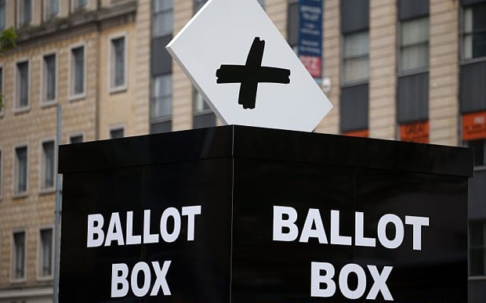

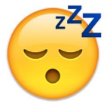

**Emoji dictionary**

Happy as can be

Happy poo

Crying with laughter

Confused/ not sure

Slightly annoyed

tired/bored of listening

okay

By Kian Pierce

Third edition – 12th June 2017

By children, for children.

DILTON TIMES

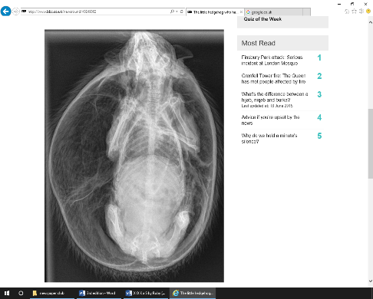

**The little hedgehog who has puffed up like a balloon**

A hedgehog was rescued by the RSPCA after it was found running around Cheshire. It had swollen to almost twice its size but is recovering well.

By Darcie Loh

**A hung parliament – what is it?**

After everybody had voted for their choice Parliament was hung post to the election. But why, and what caused it?

There are 650 MPs- 650 members of parliament, all from the Conservatives, Labour, Lib Dems (Liberal Democrats) and so on. For a party to truly win an election they have to essentially get 326 people voted into parliament- half of the 650, plus one- to automatically stay in power or be next in line for power, depending if the party who won was already in power or if they were not.

By Ruby Yates

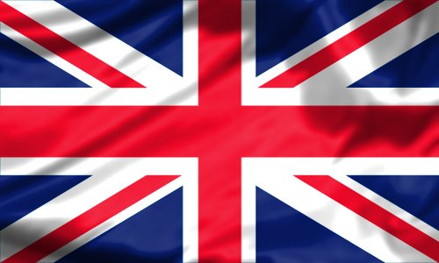

**The New X Box One X and S**

Wow! This is a new revolution in the Xbox gaming world! The Xbox One X and S is coming this November.

6 terraflops of data are packed inside this amazing item, and it has 4k graphics, meaning the popular game Minecraft can be played in 4K! The best part is that despite storage difference ALL Xbox One accessories and games are compatible with the new console. Inside the thing there is a cooling fan to keep the console from overheating.

The Xbox One X (P.Scorpio) is sure to be amazing for us!

By Ruby Yates

By Ruby Yates

Knock, knock

Who’s there?

Annie

Annie who?

Annie body home?

**Dilton’s got Talent**

Dilton’s got talent is coming to Dilton Marsh school. The previous winner was The Spice Boys! The question is, who will win this year?

If you have a special talent, why don’t you enter this year’s competition?

Coming soon to Dilton Marsh Primary School!

By Darcie Loh

Q:What is your favourite author?

A: David Walliams.

Q:who do you support in football?

A:England in the world cup

Q:if you were not a teacher what would you be?

A:I think I would be a marine biologist!

By Shannon Pierce and Jacob Broomfield

What has hands but can’t clap?

Answer: A clock!

**An interview with Miss Cray**

Q:What did you have to do to become a teacher?

A:I had to study hard at university.

Q:Have you been a teacher before?

A:Yes, but I was a teaching assistant in other schools.

Q:What do you like about Dilton Marsh?

A:I like that it feels like a big family.

Q: What is your favourite colour?

A:Red

Q:If you did not teach cherry who would you teach?

A: That’s tough, maybe Willow