;
WEEKLY NEWSLETTER
Issue No 33-2015/16

h
27th May 2016
g

Our School Council have requested colouring books, bug hunting kits & magnifying glasses for outside at lunchtimes – if you have any you no longer need, please give them to the office.

Lime Class would like donations of cakes to be brought to school on Friday 10th ready to sell at the School Fayre

Oak Class would like donations of chocolate for their chocolate tombola

Cherry & Chestnut would like bottles for their games – this could be bubble bath, fizzy drink, water, wine, lager, milk – anything in a bottle!


Menus are now on

for next term

Dear Parents,

I cannot believe that I am writing to you at the end of the term; it really has flown by! This last week has been a very busy one in school and we have celebrated Arts Week with lots of different activities. We have been very lucky to have had lots of visitors in school to work with us from various disciplines of the Arts. Interactive Drama and Orchestra with staff and students of Kingdown School, a visiting Theatre production for all classes and Mrs McLaren & Ms Redmill who helped the children create an amazing Gruffalo mural. Each class have also demonstrated great creativity and flair by making their giant British bird to fit in with our theme of Into the Woods. The birds will be on display in our woodland themed area in the corridor.

From Monday 6th June, we are going to alter the entrance format for KS2 children (Willow, Chestnut, Beech & Oak) – whilst we are very proud to have an ‘open door’ policy, we feel the older children will benefit from becoming more independent. With this in mind, we would like you to drop your KS2 child/children at the main door (even if they have younger siblings), so they can enter their classroom by themselves. This will allow the children to prepare themselves for the day and be ready for prompt registration at 8.45am. However, this new format does not mean you are unable to speak to your child’s teacher, it just means an appointment for a brief telephone call or meeting needs to be made through the office.
If your child is in Lime, Cherry or Ash class you are still very welcome to take your child to their class, but please remember the teachers need to be able to register the children at 8.55am.
We look forward to seeing the children enjoy and embrace their new responsibilities and independence.

Thank you to all of the staff, children and of course you, the parents, for the support you have given to me and Dilton Marsh School this last term. Do enjoy a relaxing half term holiday.

Jo Ronxin (Interim Headteacher)

Celebrate the Queen’s Birthday with us…

On Friday 10th June, come to school dressed in anything red, white & blue – all we ask in return is a donation for the School Fayre – this could be a tin of beans, packet of biscuits, chocolates, bottle of wine – whatever you can spare.

Achievements

Congratulations
 Dates for your Diary
May
w/c 30th HOLIDAY
June
Mon 6th Return to school
Thu 9th Cherry Class trip to Carymoor
Fri 10th Dress in red, white & blue day
Sat 11th Village Day & School Fayre
11am – 2pm
Wed 15th Kwik Cricket Competition - Warminster
Fri 17th Lime & Ash trip to Carymoor
w/c 20th Sports Week
Tue 21st *Sports Day 1.15pm (weather permitting)
Wed 22nd Oak Class to Junior Good Citizens
Thu 23rd Bikeability (Group 1)
Fri 24th Race 4 Life Sponsored Run
Fri 24th Bingo at the Social Club
Mon 27th Class photos
Mon 27th *Reserve Sports Day
Tue 28th Chestnut & Beech trip to Marwell Zoo
Wed 29th Yr 6 Taster Day at Matravers
Wed 29th Ash Assembly – NEW DATE
Thu 30th Bikeability (Group 1, part 2)
July
Mon 4^{th-} Wed 6th Yr 6 Induction at Kingdown
Tue 5th Kingdown Open Day for parents
Tue 5th Fizzpop Science assembly
Wed 6th Lime Class Celebration Assembly
Wed 6th FODS meeting 7pm at school
Thu 7th Bikeability (Group 2)
Fri 8th Yr 6 Leavers to Salisbury Cathedral
Mon 11th-Wed 13th Yr 6 Wye Valley Residential
Thu 14th Bikeability (Group2, part2)
Thu 21st Leavers Assembly (Yr 6 families only)
Thu 21st Last day of term
Fri 22nd Teacher Training Day
September
Thu 1st Teacher Training Day
Fri 2nd Teacher Training Day
Mon 5th Return to School
October
w/c 24th Holiday
December
Fri 16th Last day of term
January
Tue 3rd Teacher Training Day
Wed 4th Return to school

Weekly Class Attendance Trophy

Last week the winners were
Cherry Class & Willow Class
Congratulations

Attendance
Week Ending 20/05/16
Attendance | Absences
95.8 % | 4.2%

Learning time lost: Last week = 13 days

Reporting Absence
Please notify the office of absence and the reason for it before
9.00am each day.
Tel: 01373 822902 or e-mail office@diltonmarsh.wilts.sch.uk

School Registration times:

KS2-8.45am
(Willow, Chestnut, Beech, Oak)
KS1- 8.55am
(Lime, Cherry & Ash)

Christian value for the month is:

Each month we will have a focus on an important value in our school which will be high profile in class and feature in Assemblies

Truthfulness

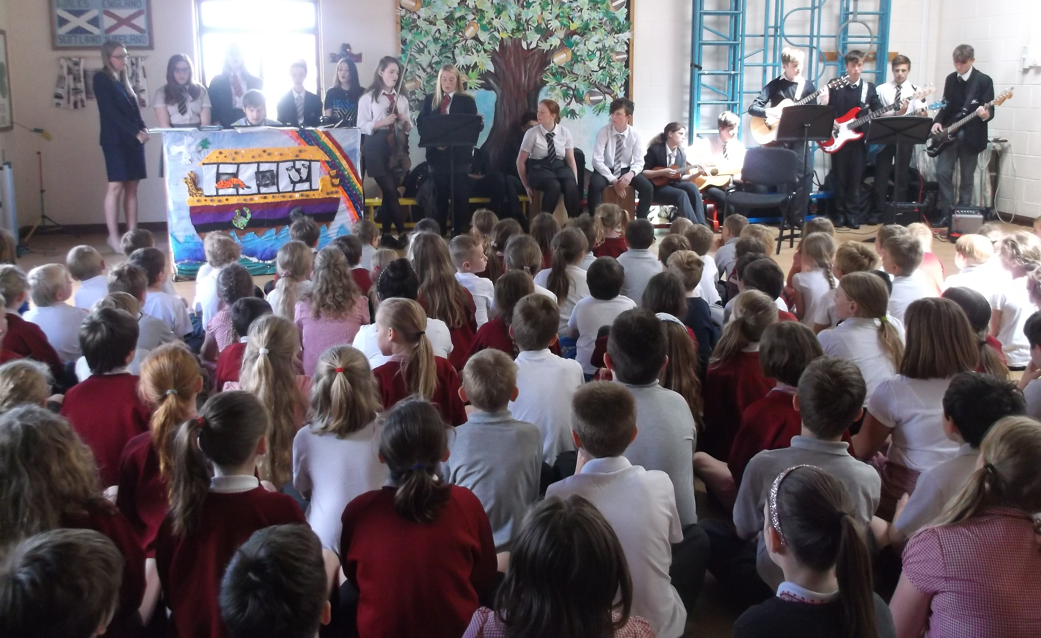
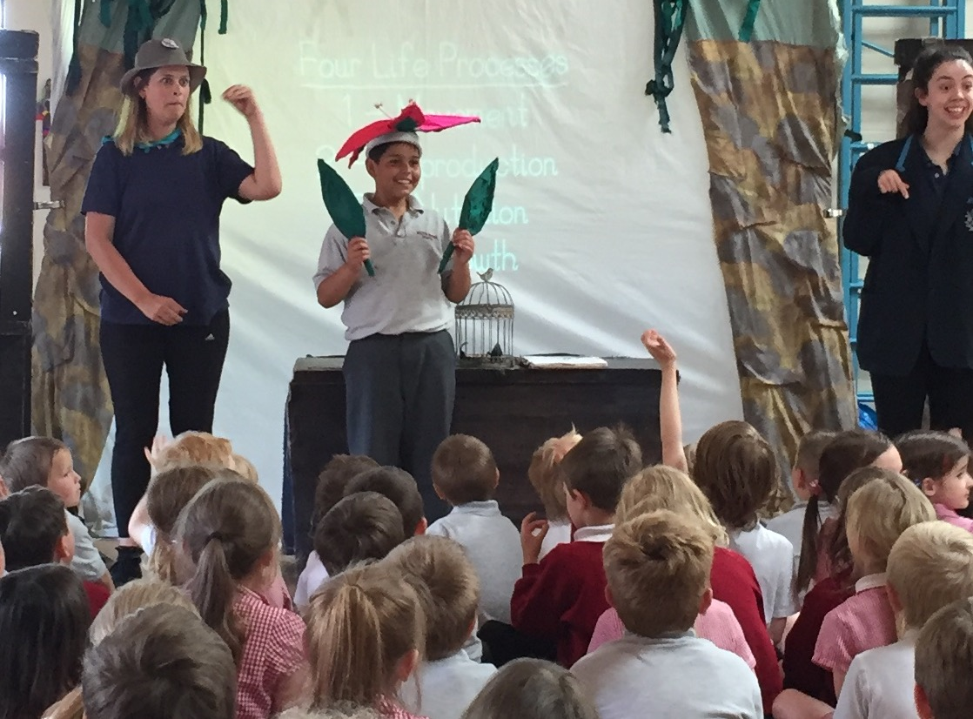

COMMUNITY COHESION

Lunch Guests
This week we welcomed PC Pullen from Wiltshire Police
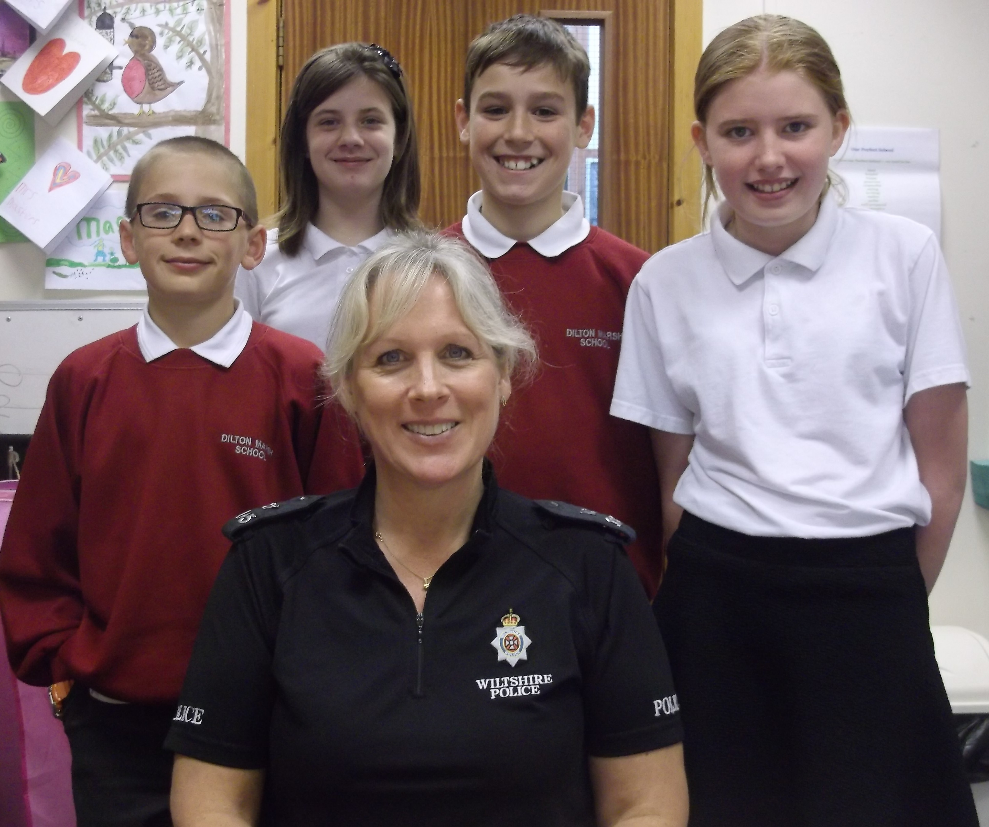
James, Niemh, Joe & Holly entertained our guest with
Creamy Ham & Mushroom Pasta Bake followed by Chocolate Trifle
…….
Please bring in your Sainsbury’s tokens
Thank you
………
Join us in finding the cure for Type 1 Diabetes! www.jdrf.org.uk
Joint raffle JDRF and The Pony Club
£1 per strip available from the office.
Many, many prizes (see posters)
Will be drawn on 12th June’16
………
LITTERPICK
Saturday 4th June 1000am - 1200
Meet at the gate of Holy Trinity Church.
Wear suitable clothing.
Bring your own gloves
Help to keep our village clean!
Catering Assistant – 2 hours per day – 12 to 2.00 pm each day - term time only - Hourly rate £7.00
Extra hours will be offered to cover staff illness etc
We require a Catering Assistant to join our busy catering team, providing meals for our children. General Kitchen duties will include;
Some food preparation, washing up (we do have a dish washer), tidying and cleaning the kitchen to meet our 5 star Environmental Standard, clearing away the tables and chairs in the hall ready for the afternoon.

A level 2 food hygiene certificate would be an advantage but not essential as we can arrange for you to sit this in school.

Application forms are available from our website www.diltonmarsh.wilts.sch.uk or by contacting the School Officer Tel 01373 822902 or email admin@diltonmarsh.wilts.sch.uk

Dilton Marsh CofE Primary School is committed to safeguarding and promoting the welfare of children and young people and expects all staff and volunteers to share this commitment. All applicants will be subject to a full Discloure And Barring Service check before appointment is confirmed.


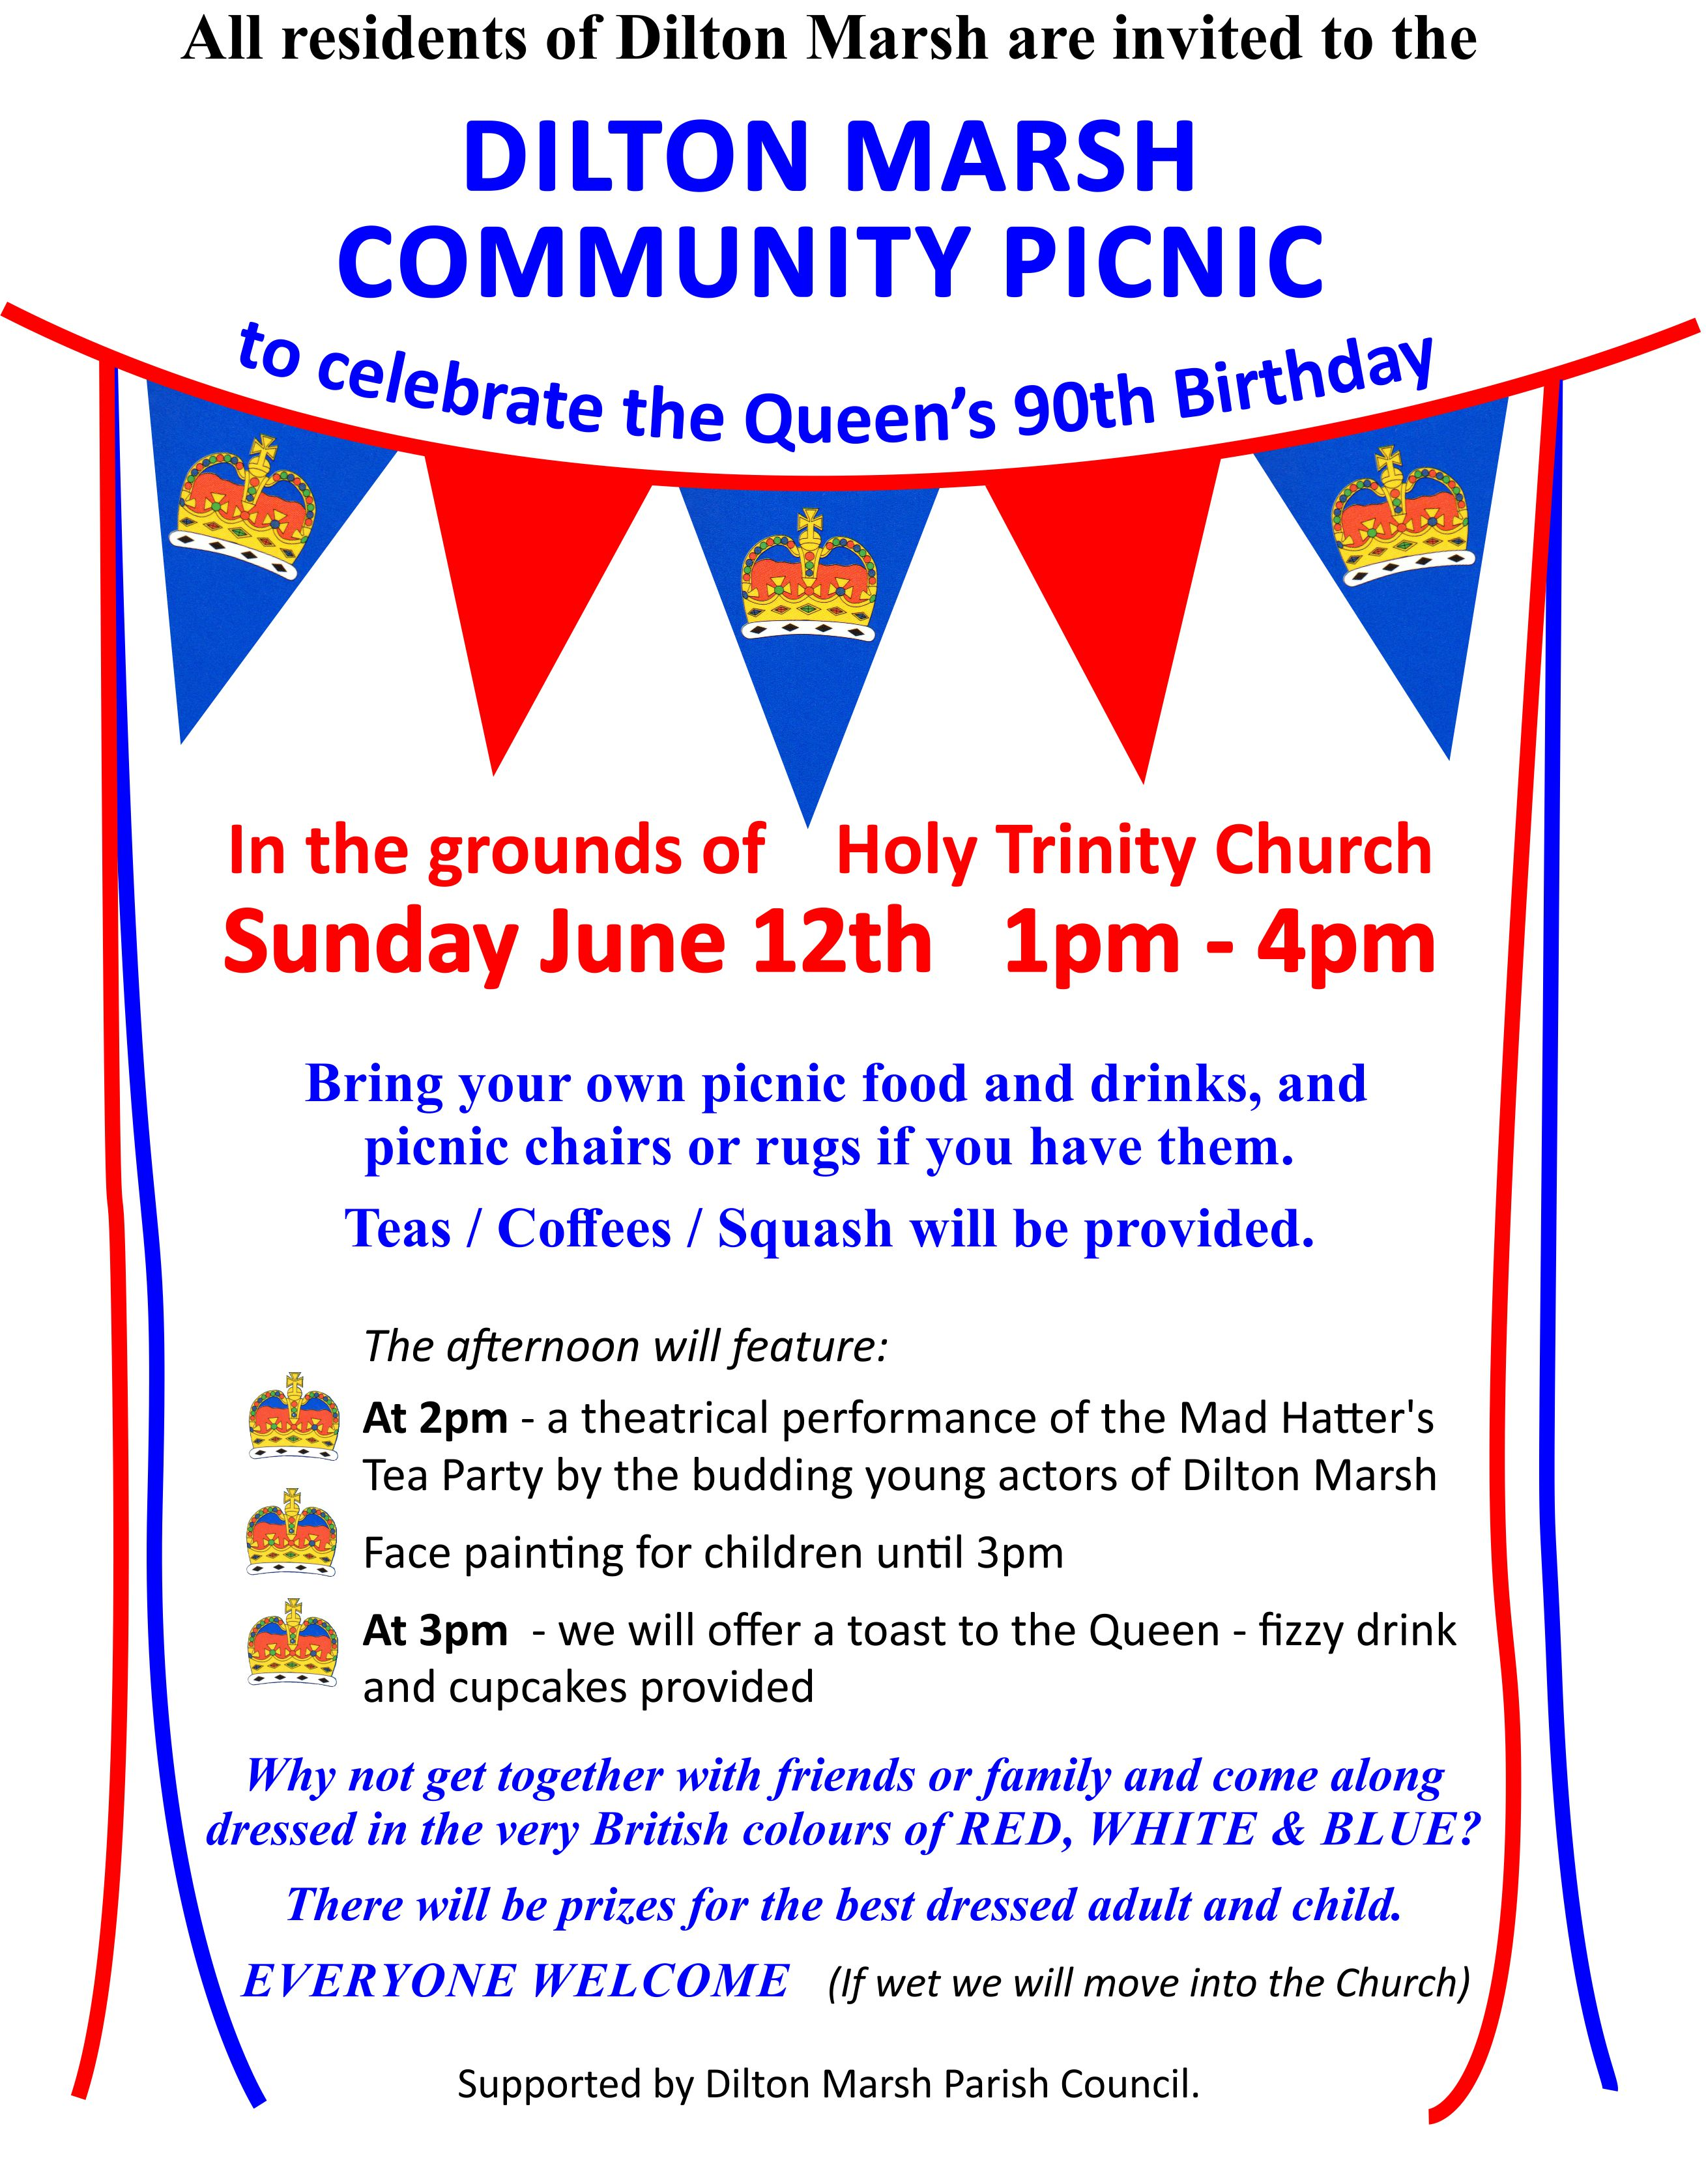

Holiday Birthdays
Alex(10) Carmella(6) Josh H(6) William S(7)
Anthony(8) Oscar(8) Joshua G(5) Solomon M(5)
Elsa(6) Lyra(6) Adam(11)

FODS UPDATE…

Thank you for supporting our recent events:

- The Scarecrow Trail raised approx £380, along with a very kind donation of £92 from the Church refreshments

- School disco raised £229.15

- Bingo Night is arranged for Friday 24th June at Dilton Marsh Social Club

- Planning for the Summer Fayre is well under way – if you can help run a stall for ½ hour, please add your name to the list in main reception. Also, please bring in donations for the raffle, tombola, chocolate tombola, bottle stall or cake stall when we return after the holiday.

Thank you

Events at
Trowbridge Museum:

Wednesday 1st June: Picture Perfect
Join us for a bit of painting and drawing as we create pictures reflecting the summer season.
This workshop is suitable for ages 5+ and tickets will be issued from 10am for sessions starting at 10.30, 11.10 and 11.50 and from 1pm for 1.30, 2.10 and 2.50 sessions.

Wednesday 1st June – 5.30 – 8.30: Flower Art Workshop
In this relaxed art session for adults you’ll be creating flower-themed artworks using a range of materials and techniques. Places are limited and cost £10 per person (£8 Friends of Trowbridge Museum). To reserve a place come into the museum (£5 deposit required) or book via Ticketsource.

Thursday 2nd June: Picture Perfect
Come along and have a go at creating flower-themed artworks using a variety of materials and techniques. These workshops are suitable for ages 12 plus and cost £3 per person and should be booked in advance as places are limited. Sessions at 10.30 – 12.30 and 1.30 – 3.30. Book in the museum or via Ticketsource.

Friday 3rd June: Decorate-a-Bag
Come along and join in the cutting, sticking and sewing as we decorate small tote bags. Suitable for ages 4+. Tickets will be issued from 10am for sessions starting at 10.30, 11.10 and 11.50 and from 1pm for 1.30, 2.10 and 2.50 sessions. This is a free workshop but a donation would be appreciated.

Achievements

Sophie passed Stage 3 swimming

Isabella earned Badge 7 Gymnastics

Congratulations
New!!!
Ofsted Registered Childminder based in Dilton Marsh will be available after half term for before and after school childcare.
Please contact Phoebe 07725 333125 or 01373 858196.




