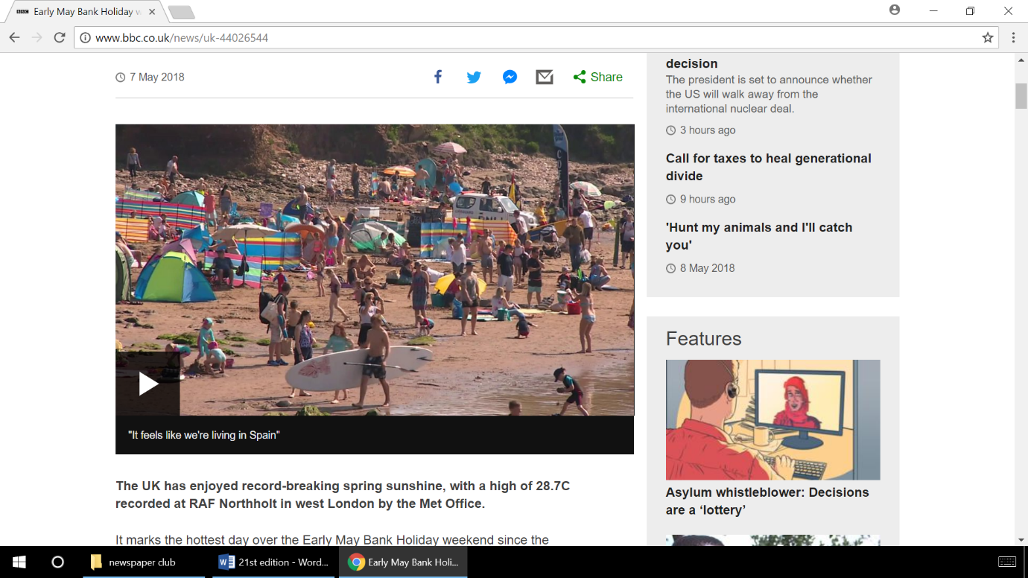

**Volcano erupts in Hawaii!**

Nearly 2000 people have been evacuated from their homes in Hawaii because of a volcano in Hawaii. Kilauea volcano has already destroyed 26 homes and is threatening others. So far, nearly 2000 people have been evacuated. On Sunday night, new cracks appeared in the ground – called volcanic fissures – where lava leapt up to 70 metres into the air. On Friday, the island was hit by a powerful 6.9 magnitude earthquake.

Many people are unable to return to their homes and have having to stay in emergency shelters. Who know how long this can go on for! Kilauea is the world longest continuously erupting volcano and has been erupting since 1983, that’s 12775 days!

By Theo Baalham

21st Edition – 8th May 2018

By children, for children.

DILTON TIMES

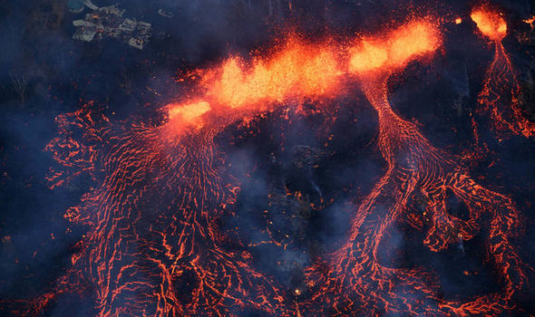

**Happy Birthday David Attenbourough!**

Today (8th May 2018) happens to be David Attenbourough’s birthday. He finally reached 92 years of age!

By Theo Baalham and Chalie Oley

**Hot weather comes back for bank holiday!**

Can you believe how lucky we are? The pleasant time on Monday (the early May bank holiday) was very relaxing. Did you know, it actually went up to 27 degrees- nearly as hot as Barbados! Much of the UK was blessed with scorching temperatures and sunny, clear skies all (LONG) weekend. The highest temperature in London on Sunday was 28 degrees, 23.6 degrees in Wales, 21.8 degrees in Scotland and 20.8 degrees in Ireland.

I hope you didn’t forget your sun cream!

By Charlie Oley

# **Pokémon Game Review**

The game in the Pokémon series (Pokémon Ultra Sun and Ultra Moon) tops all the others. You begin with three starter Pokémon, Litten, Popplio and Rowlet. The main character, Lily, has a Cosmog called Nebby and a villain chasing her called Faba. He wants Nebby to make an Ultra Wormhole so he can meet Necrozma and take over the Alola region. This game introduces new Pokémon such as Zeraora. You can catch any Pokémon you want, plus there are over-powered moves called Z-moves which each Pokémon can use!

By Riley Chalke and Archie Peters

**Guess what’s back? Eurovision!**

Everybody’s getting excited in various different countries. Why? Eurovision’s starting again, and it’s kicking off tonight (8th of May; the semi-finals are, at least)! This year’s competition is taking place in Portugal, and is the first ever time it has ever taken place there. This evening Azerbaijan, Iceland, Albania, Belgium, the Czech Republic, Lithuania, Israel, Belarus, Estonia, Bulgaria, FYR Macedonia, Croatia, Austria, Greece, Finland, Armenia, Switzerland, Ireland and Cyprus are taking part in the prestigious semi-finals. Our performer’s name is SuRie, and we hope she’ll do wonderfully!

By Ruby Yates



**How will things get stranger?**

Get ready for strange things to blow your mind!

Kid sized Meghan and Harry have a serious case of Royal. Wedding. Fever.

They re-enact their proposal- perfectly. Meghan says yes and jumps up and down waving her hands in the air. Then they hug and look at the camera with a smile on their faces.

Frog gets ready for the bus arrival- no, a rooster, not a frog.

When Savannah arrives at home, the little rooster jumps into her arms. Happy music cue. Wait, no music? Ok…

And Plastic King Robert has a dream to secure his needs and his island’s- castle of plastic! With some help, the dream came true! Just imagine it.

That’s it for this week but if Strange things aren’t in our newspaper, you can always check it out on Newsround weekly.

By Caroline South

**Star wars: The Last Jedi Film Review**

The Last Jedi is the newest films of one of the most world famous series ever, Star Wars and it is the eighth one of them. Rey the main character in the movie learns how to control the force(the force is an energy that flows through everything but is separated into two parts the light and the dark) by the most well-known character Luke Skywalker he is the best and only Jedi left in this film. Rey was sent to find Luke at the end of the Force Awakens (film before the last Jedi). We would definitely recommend this film to you. Also you may like a company that uses bricks that can connect called Lego and they do Lego star wars and many star wars creations are made from these amazing movies. So put on your TV, insert the disc and get watching the amazing Last Jedi.

By William Slarke and Harry Lawrence