The Dilton Dozen Reading List – Year 1 & 2

Spring Term

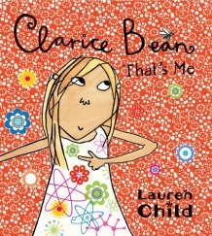
Clarice Bean, That's Me

by Lauren Child

In the chaotic Bean household, Clarice - an engaging and quirkily original heroine - has difficulty finding any peace. Certainly, there is none in her bedroom, which she has to share with her younger brother Minal (who likes to hang upside down until he turns purple), and where all her things are crammed into the tiniest of spaces. Meanwhile her boy-mad older sister and other brother Kurt (struggling with his perplexing adolescence), have rooms of their own to go to. Even the grown-ups have their bolt-holes: Dad gets to escape to the office, Granddad to his comfy chair and Mum to the bathroom. Only when Clarice openly rebels does she finally succeed in getting the peace and quiet she really wants.

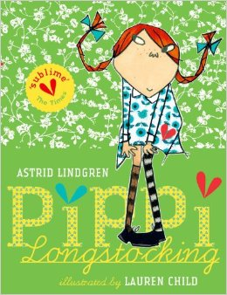
Pippi Longstocking

by Astrid Lindgren
Follow Pippi Longstocking on her amazing adventures as she moves into Villa Villekulla with a horse, a monkey, and a big suitcase of gold coins, and meets Tommy and Annika who quickly become her best friends. They join her on her amusing escapades – joining the circus, dancing with burglars and celebrating her birthday.
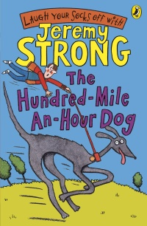

The Hundred-Mile-An-Hour Dog by Jeremy Strong

A Children's Book Award winner that tells about Streaker, a rocket on four legs with a woof attached. Children giggle uncontrollably at the humour, and it will raise a smile in mums and dads as well.

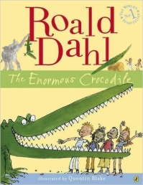
The Enormous Crocodile by Roald Dahl

The Enormous Crocodile is a horrid greedy grumptious brute who loves to guzzle up little boys and girls. But the other animals have had enough of his cunning tricks, so they scheme to get the better of this foul fiend, once and for all!
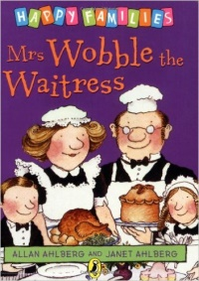

Mrs Wobble the Waitress and other Happy Family Stories by Allan Alberg

Mrs Wobble loves her job as a waitress in a cafe but there's one big problem - she wobbles! She wobbles so much that she drops a chicken on a lady's pretty hat, then she drops a jelly on her boss and gets the sack. She fears her wobble will stop her working ever again - but Mr Wobble has a plan...

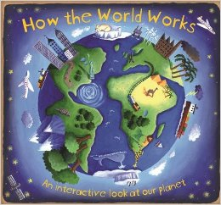
How the World Works Christiane Dorion

How did life begin? Is the earth moving beneath our feet? Why does it rain? Encompassing all of these questions and many more, this fun, engaging, interactive book introduces the Earth's important cycles and encourages children to think about the impact of human actions on our world, inspiring respect for the natural world and all its harmonies.

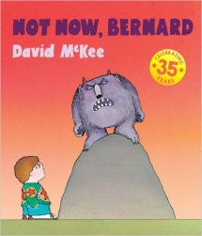
Not Now, Bernard David McKee

Bernard's got a problem. He's found a monster in the back garden but his mum and dad are just too busy to notice. So Bernard tries to befriend the monster… and that doesn't go quite to plan.

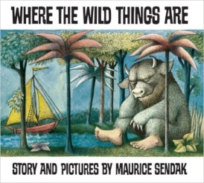
Where the Wild Things Are By Maurice Sendak

One night Max puts on his wolf suit and makes mischief of one kind and another, so his mother calls him 'Wild Thing' and sends him to bed without his supper. That night a forest begins to grow in Max's room and an ocean rushes by with a boat to take Max to the place where the wild things are. Max tames the wild things and crowns himself as their king, and then the wild rumpus begins. But when Max has sent the monsters to bed, and everything is quiet, he starts to feel lonely and realises it is time to sail home to the place where someone loves him best of all.

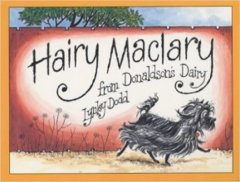
Hairy Maclary from Donaldson’s Dairy By Lynley Dodd

Hairy Maclary goes off for a walk in town, followed by a few friends. All is uneventful until they meet Scarface Claw, the toughest tom in town, and run for home

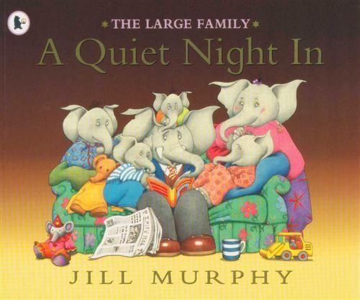
A Quiet Night In by Jill Murphy

It's Mr Large's birthday and Mrs Large has prepared him a meal, as they're going to celebrate with a quiet night in. But as usual in the Large household, things don't go to plan, and Mr and Mrs Large fall asleep on the sofa! So the little Larges sneak off to bed with all the lovingly prepared food...

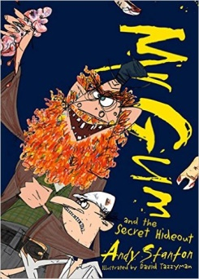
Mr Gum and the Secret Hideout by Andy Stanton
Shabba me whiskers! It’s one of those Mr Gum books by Andy Stanton. They’re only the craziest, funnest most amazing books for children in the world.
Good evening. Talking parrots in the rooftops? A giant cactus on the high street? Mosquitos so nasty that even their own friends don’t like them? Something’s gone terribly wrong in Lamonic Bibber . . . and Mr Gum is nowhere to be found. Yes, folks, Polly and Friday are facing their biggest challenge yet. So strap yourselves in, cry ‘HI-HO-WEIRDY!’ and get ready for an adventure so crazy your feet will melt with happiness! And I’m not just saying that, I’ve actually seen it happen. HOORAY!

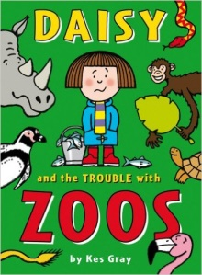
Daisy and the Trouble with Zoos by Kes Gray

It's Daisy's birthday and she's having a special birthday treat! Mum has invited her best friends, Gabby and Dylan, on a trip to the zoo - and, best of all, Mum has arranged for Daisy to go into the actual penguin cage with the actual zoo keeper and FEED actual penguins! REAL ACTUAL PENGUINS! With actual beaks and everything!! Trouble is, Daisy doesn't just feed the penguins, she 'adopts' one to take home and everything.

