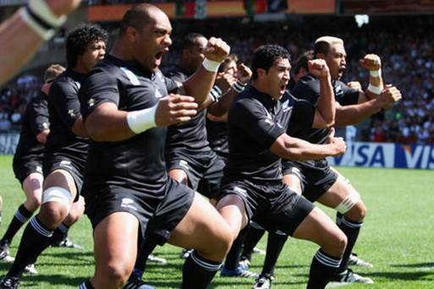

**The X-ray space telescope searching for black holes**

China has just launched its first

x-ray space telescope! With the Nick-name insight it will be used to find out useful information about black holes.

By Wilf Hewitt-Grainger

Fourth edition – 3rd July 2017

By children, for children.

DILTON TIMES



**Lego World game review**

Have you heard of Lego Worlds? It’s amazing! It’s a mixture of Lego and Minecraft, two popular brand lines, in one game. With grappling guns, lanterns, gemstones and **lots** of skeletons there’s never a dull moment away as you fire paintballs at walls, ride a lion down a savannah and ride pigs away from witches!

This completely random game has no limit except your imagination. A castle in the sky? A giant octopus house in a jungle? A giant Lego sign you can climb up? Anything is possible in this creative, wonderful game!

By Ruby Yates

By Ruby Yates

**World record for the Haka!**

As the New Zealand Lion’s tour is getting in to full swing, the legendary All Blacks have been competing against such teams as Great Britain and Ireland. Along with their ruthless rugby playing they are most famous for their performance of the Haka. But the Haka has been popular with everyone in New Zealand, not just those performing on a pitch.

Recently, thousands of people got together to show their scary faces in the Haka in an attempt to break the Guinness World Record.

Imagine watching a Haka performed by 7000 people?

By Darcie Loh

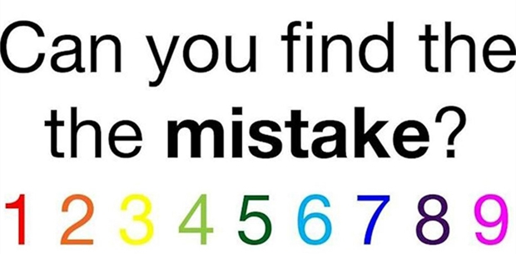

**New Puppy Police!**

In Taiwan, the police force have got some new recruits. As you probably know by the title they are PUPPIES and are super, super cute! A litter of 6 puppies born from two current police dogs were born on the 9th of May. The police dogs’ puppies are called Lucky Star, Schumann, Fly, Brother, AJ and Bright. Lucky Star really is a lucky star because he’s the only golden pup in the litter! It’s hard to think that one day these sweet beauties will be helping to get crime down in Taiwan some day!

By Ruby Yates

**What is the ‘Baby Shark’ craze?**

Dilton Marsh Primary school has a famous song which has dominating the classrooms. The song is called ‘Baby Shark’ and is incredibly repetitive.

Chestnut and Cherry class have already been learning the dance and singing the tune.

It is a love it or hate it kind of song!

By Darcie Loh

**An interview with Ms Aide**

Q: What did you have to do to become a teacher?

A: GCSE, A Level and degree at Bath Spa.

Q: Were you a teacher before now?

A: Yes a Montessori teacher and other local schools.

Q: What do you like about Dilton Marsh?

A: Beautiful school, family feel, polite and helpful staff and funny Miss Tout.

Q: What’s your favourite colour?

A: Black to wear, green and blue in general.

Q: Who’s your favourite author?

A: Roald Dahl

By Shannon Pierce

**Sports section**

The professional tennis season is made up of hundreds of tournaments around the world and one of the most prestigious is Wimbledon.

So if you fancy yourself a bit of a tennis buff, or you simply want to know more about the whole thing ,then this fact attack is for you.

From match played, to strawberries and cream eaten, we give you Wimbledon in numbers.

By Kian Pierce and Jacob Broomfield