## ­­­

Design Technology:  
In Design Technology we will be designing, making and evaluating houses for the Three Little Pigs. We’ll even be testing them to see if they would withstand a visit from a hungry wolf!

History:  
This term, our history focus is ‘The Great Fire of London’. We will look at how the design of houses and towns has changed through time and why. We will also look at the life of Samuel Pepys and will be learning why he is an influential person in our history.

Science:  
This term we will be learning about materials. We will be doing investigations to understand the properties and uses for different types of materials. We will then use this knowledge in our DT to make and test our own houses!

Art:  
We are very lucky to be having Mrs Masters teach us for Art this term!

Literacy:  
In Literacy this term we will be focussing on ‘The Jolly Postman’. He will help us to learn about traditional tales, in particular, ‘The Three Little Pigs’. We will be doing lots of drama, story writing, making posters and will be writing diary entries to tie in with our History topic. As ever, we will also continue to work on our spelling, punctuation, grammar   
and handwriting.

Computing:  
We are doing a programming unit this term. We will be learning the commands left, right, forwards and backwards and will be using these to program our friends and bee-bots to desired locations.

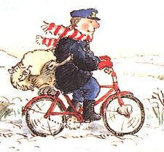

French   
Madame Sturm will continue teaching us French this term.

Music:  
Our Music will continue to be taken by Mrs Lawrence this term.

PE:  
In PE we will be developing our dance skills. We will be learning how to travel in different ways, in different directions and at different speeds, with control. We will also start doing this in time to music.

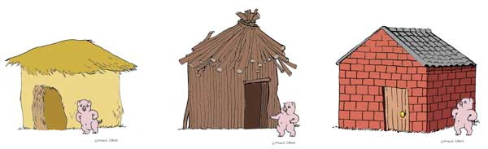

RE:  
We will be learning about the importance of friendship this term. We will learn how Jesus befriended different people and how he was a good friend. We’ll also explore how we can be good friends and help each other.

Geography:  
We’re going to use globes to learn about the continents, oceans, hot and cold areas of the Earth. We’ll also look at the features of each by using aerial photographs and geographical vocabulary.

Maths:  
In Maths we will start the term by looking at 3D shape. We will learn to name and identify: cubes, cuboids, pyramids and spheres. We will then recap our addition and subtraction skills, tying in our number bonds to 10 and 20. We will then finish the term by learning how to tell the time to the hour or half-hour, using analogue clocks.

PSHE:  
This half term, PSHE will focus on   
Friendship. We will look at the  
 importance of individuality, sharing and what it means to be a good friend. We will also be ‘Going for Goals’; learning about the importance of target setting. We will be setting class and individual goals and will be reviewing these regularly.