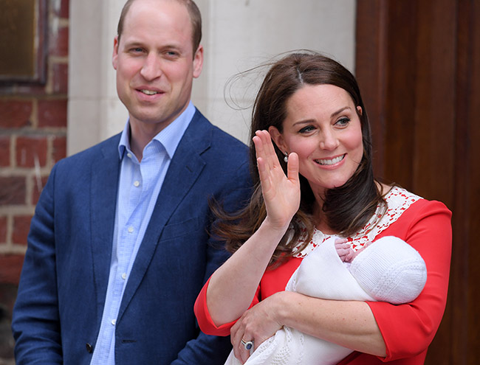

19th Edition – 20th April 2018

**Why does the Queen have two birthdays?**

Queen Elizabeth really only has one birthday, but she get to celebrate not one, but two birthday. Why? It is a royal tradition to have two birthdays because King George II began this tradition more than 250 years ago, in 1748. He was born in November which isn’t a loved month, notorious for its mix of Autumnal and Wintry weather. Wanting to celebrate it in style, he mixed it in with a summer military parade. This is how the double birthdays began!

For her ‘official birthday’ in June, the Queen celebrates the day publicly with a huge parade in London Called Trooping the Colour.

By Charlie Oley

By children, for children.

DILTON TIMES

**An Amazing Marathon**

On Sunday the London Marathon took place! 1000s of people made it to the finish including Noah Savides’ dad. One person was running for his farther but fell down dead! The London Marathon was very popular to watch. The runners ran for charities and different reasons they also made lots of progress throughout the race. This race is so far it is over 356 football pitches! Some people took over 5 hour to complete the race.

By Theo Baalham

**Another Royal Baby!**

The Duchess Of Cambridge has given birth to her 3rd bundle of joy- and it’s a prince!

The Duchess was admitted to St Mary’s Hospital, which is in Paddington (not the bear, the area),London, in the early stages of labour on Saint George’s Day (23rd of April). She was admitted to the Lindo ward and many loyal royal fans congregated outside, waiting to find out about the Duchess and their child. Many were holding banners, emblazoned with things like “It’s A Princess!” and “It’s A Prince!”

As well as having wonderful parents and sweet siblings (Charlotte and George) the baby is the 5th in line to the throne- after Prince Charles, Prince William, Prince George and Princess Charlotte!

The boy is also Queen Elizabeth’s 6th great grandchild.

There is even more positive royal news on its way, as Harry and Meghan are getting married soon. The skies are looking bright for this historic royal family!

By Ruby Yates

# **Social site reporting for duty!**

Our government ordered social media sites to set out how they plan to make sure children are safe online.

The health secretary, Jeremy Hunt, has written to social networks like Instagram and Google, and wants them to respond by 30th April.

He wants to know how they’ll cut underage use, prevent cyber bullying and promote a healthy screen time (well, atleast healthier than before).

Jeremy says they’re “turning a blind eye” to their impact on children who are underage and ignoring that they, and many other users, are underage.

**Did You Know?**

You have to be 13 to get Facebook, Instagram and more!

By Caroline South

# **Have Scientists found a way to reuse plastic?**

Plastic is a big problem at the moment.

Lots of people are working hard to find ways that can reuse plastic… and some scientists believe they have found the answer to this global and vastly affecting problem!

The answer comes to the call of bottles being made of a material named PET, which takes a long time to disintegrate into nothing. Many people are dropping these bottles, and are polluting our parks, forests, wildlife and bodies of water.

Let’s hope this works!

By Riley Chalke

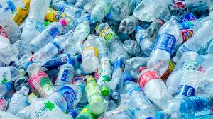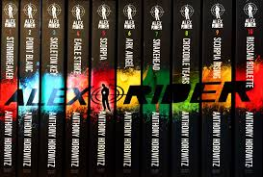

**Book Review**

The bestselling Alex Rider books were created by Anthony Howowitz and you should get them! The first book was created on 3rd May 2000 and was published in 2001, being called Alex Rider STOMBREAKER. In the book, Alex riders uncle gets killed in a car crash (well the police say so) but Alex knows that it is not true. the next day he gets told by Alan Blunt (head of MI6 special operations) that all these years his uncle has been training him to work for MI6 but Alex refuses.

The main villain is called Herod Sayle age unknown Bio: Born in Beirut his dad was a failed hairdresser.

By Archie Peters and William Slarke

**The Poop train is going to different states**

The poop train is a train is a train filled with litter that people have dropped on the ground and has made a very smelly little place in Parrish in the USA. They sent it off in New York and has been going for a very long time and has reached a whole other state called Alabama and will carry on going and will soon go to the landfill site. Unfortunately the people in the little town of Parrish had the poop train stopped at their sport fields so the choo choo turned into the poo poo!

By Harry Lawrence