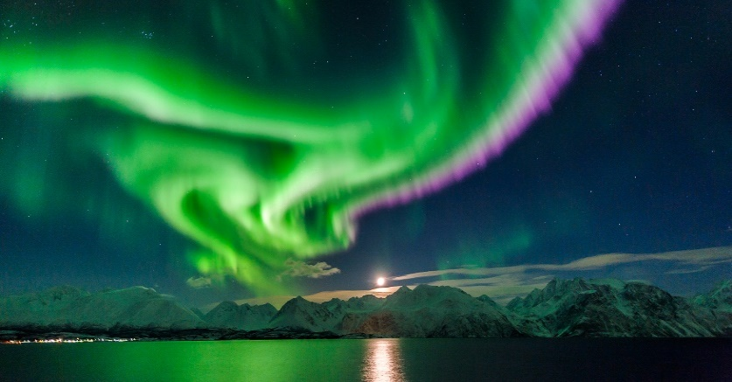

**Should Pokémon cards be banned?**

Pokémon cards are an amazing trading trend that we as a school have become addicted to. Our school playground is now packed with Pokémon lovers and battling breakouts.

There are different types of cards, too. Some are shiny cards, but some can help boost your attack stat or can relieve your Pokémon of special effects.

It’s become such a craze that people who did not even know about them or like them now have hundreds of thousands of these highly collectible cards.

**But should they be banned?**

In classes some teachers have become very annoyed after seeing students browsing their card collection in lessons, not really concentrating on their work.

And now trading has been banned from the ratio, too.

Students feel angry and confused because trading is pretty much the base of the popular game, as its name is The Pokémon Trading Card Game (or TCG). Just because children have been upset about unfair trades doesn’t mean they should stop trading for everybody.

But with Teachers getting more and more paranoid about children not paying attention to learning, is this the end of the Pokemon TCG for Dilton School………?

By Jay Kinzett, Rebekah Slarke and Ruby Yates

Fifth edition – 12th September 2017

By children, for children.

DILTON TIMES

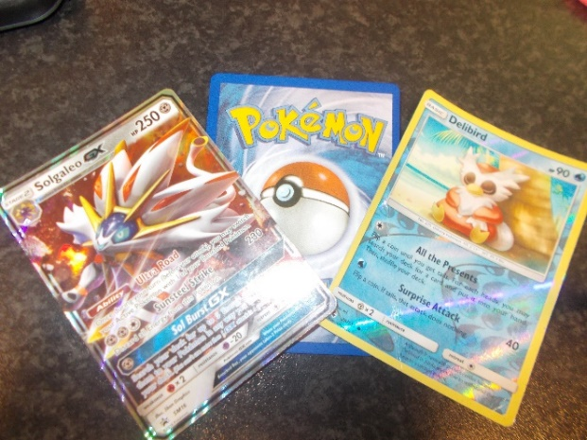

**Joke station**

Knock knock,

Who’s there?

The door.

**The Aurora Borealis**

On Friday the borealis appeared in places as far south as Edinburgh in Scotland and Arkansas in the USA.

But what causes the northern lights to happen? The northern lights are actually caused by electrons from solar winds. These mix with the atmosphere, causes the gases to glow.

By Amelia F and Freya H-R

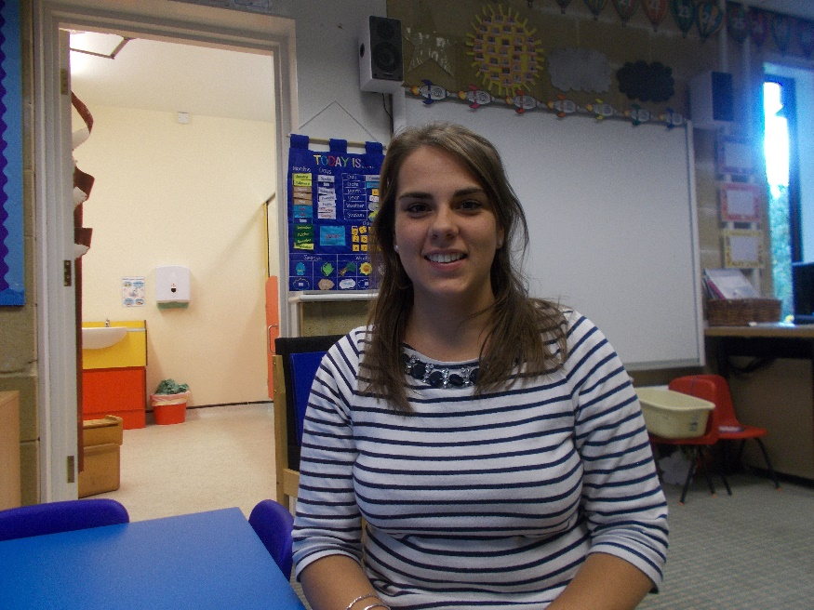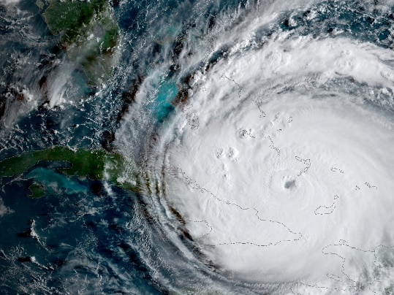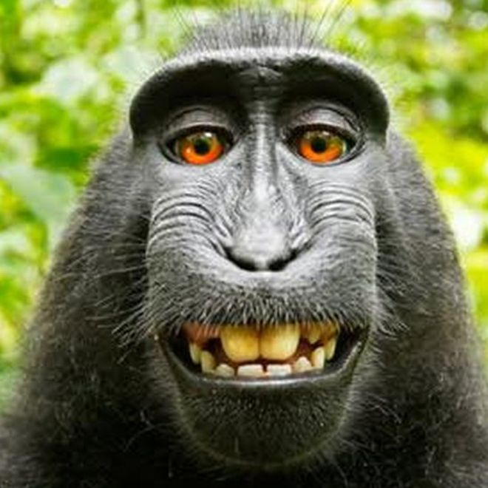

**Hurricane Irma**

The UK has promised £32 million in help and along with France and the Netherlands are sending rescue teams and emergency supplies to help. Huge areas in Florida are without power, and parts of the city of Miami are under water.

By Wilf HG and Oscar

**The Crazy Monkey selfie!**

A monkey became famous in 2011 because she took a selfie. When she got hold of David slater’s camera- the photographer- she held it in front of her and gave a big smile and took a picture. In 2016 a US court decided that the monkey did not legally own its own picture and the photographer won the rights. Still, it’s a very cool picture!

By Charlie Oley

**An interview with Miss Williamson**

Q: What would you be if you were not a teacher?

A: An event planner.

Q: What is your favourite part about Lime class?

A: The children make me laugh.

Q: What’s your favourite colour?

A: Fushcia.

Q: If you weren’t in Falcon, which house would you like to be in?

A: Kestrel because I like the colour blue.

Q: Where was your previous school?

A: Bemerton st John, Salisbury

By Shannon Pierce