The Dilton Dozen Reading List – Year 5 & 6
Spring Term
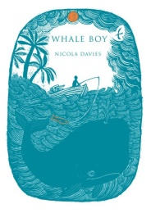
Whale Boy – by Nicola Davies
Michael Fontaine’s dreams are about to come true. He’s finally going to get his own boat, catch his own fish and have the freedom to spend his time doing what he loves best - being out on the ocean. But when a mysterious company descends on the island of Liberty, Michael’s plans are ruined.

The NME, led by the suspicious Spargo are claiming to bring trade and tourism to the island with focus on its marine wildlife, but whales haven’t been spotted near Liberty for years. So when Spargo offers Michael his own boat and paid work watching the water for signs of whales it seems too good to be true – but why does the job come with the condition that he must keep it a secret from everyone he knows?

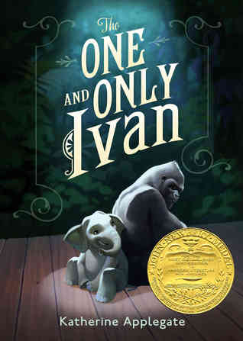
The One and Only Ivan - by Katherine Applegate
Winner of the Newbery Medal 2013. Inspired by a true story, this is the beautifully written tale of how a mighty gorilla wins his freedom. A winning blend of humour and poignancy that will appeal to fans of Michael Morpurgo. Ivan is an easy-going gorilla who has spent his life performing for the crowds at the Exit 8 shopping mall. He rarely misses life in the jungle. In fact, he hardly thinks about it at all. But everything changes when a baby elephant called Ruby arrives and Ivan realises he must find a new life for them both. Told from Ivan's perspective.

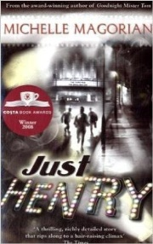
Just Henry - by Michelle Magorian
This is a mystery-thriller and an insightful snapshot of time, set in post-war Britain. It's 1949 and life is bleak for Henry. He misses his father who died a war hero, and he escapes from his annoying stepfather and stepsister whenever he can and goes to the cinema - his passion. One day in the cinema queue he meets Mrs Beaumont who also loves films, and lends Henry a camera for his school project. Henry is disgusted that he's been put in a group with Jeffries, the son of a man who went AWOL, and Pip, who was born illegitimate; but he's about to learn that tolerance and friendship are more important than social stigmas. Henry will need his new friends when he processes the film and makes an alarming discovery. Like a bomb waiting to explode, Henry's world is about to unravel. Just Henry won the 2008 Costa Children’s Book Award.

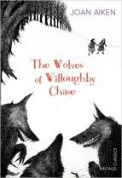
The Wolves of Willoughby Chase - by Joan Aiken
Can you go a little faster? Can you run? Long ago, at a time in history that never happened, England was overrun with wolves. But as Bonnie and her cousin Sylvia discover, real danger often lies closer to home. Their new governess, Miss Slighcarp, doesn't seem at all nice. She shuts Bonnie in a cupboard, fires the faithful servants and sends the cousins far away from Willoughby Chase to a place they will never be found. Can Bonnie and Sylvia outwit the wicked Miss Slighcarp and her network of criminals, forgers and snitches?

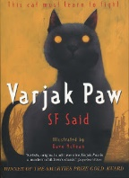
Varjak Paw - by S. F. Said
Varjak Paw is a Mesopotamian Blue kitten. He lives high up in an old house on a hill. He's never left home, but then his grandfather tells him about the Way - a secret martial art for cats. Now Varjak must use the Way to survive in a city full of dangerous dogs, cat gangs and, strangest of all the mysterious Vanishings. SF Said's first book, Varjak Paw, won the Nestle Smarties Prize for Children's Literature. The sequel,The Outlaw Varjak Paw, won the BBC Blue Peter Book Of The Year.

Scarlet Ibis - by Gill Lewis
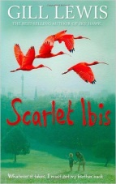
Red asks, 'Will we always be together?' 'Always,' I say. 'Just you and me in that little boat, watching the scarlet ibis flying back to the Caroni Swamp.'

Scarlet's used to looking after her brother, Red. He's special - different. Every night she tells him his favourite story - about the day they'll fly far away to the Caroni Swamp in Trinidad, where thousands of birds fill the sky. But when Scarlet and Red are split up and sent to live with different foster families, Scarlet knows she's got to do whatever it takes to get her brother back. (Other books that you might enjoy from this author are: White Dolphin and Sky Hawk)

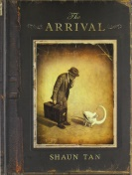
The Arrival - by Shaun Tan
What drives so many to leave everything behind and journey alone to a mysterious country, a place without family or friends, where everything is nameless and the future is unknown. This silent graphic novel is the story of every migrant, every refugee, every displaced person, and a tribute to all those who have made the journey.

Time Travelling with a Hamster - by Ross Welford
Laugh, cry and wonder at this race-against-time story of a boy who travels back to 1984 to prevent a go-kart accident, and save his father's life...

My dad died twice. Once when he was thirty nine and again four years later when he was twelve. The first time had nothing to do with me. The second time definitely did, but I would never even have been there if it hadn't been for his 'time machine'... When Al Chaudhury discovers his late dad's time machine, he finds that going back to the 1980s requires daring and imagination. It also requires lies, theft, burglary, and setting his school on fire. All without losing his pet hamster, Alan Shearer...

The Person Controller - by David Baddiel
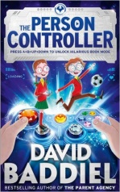
Fred and Ellie are twins. But not identical (because that's impossible for a boy and a girl). They do like all the same things, though. Especially video games. Which they are very good at. They aren't that good, however, at much else - like, for example, football, or dealing with the school bullies. Then, they meet the Mystery Man, who sends them a video game controller, which doesn't look like any other controller they've ever seen. And it doesn't control any of their usual games. When the twins find out what it does control, though, it seems like the answer to all their problems. And the key to all their wildest dreams. At least it seems like that.. Whether it’s scoring the winning goal in the biggest football match of the season or standing up to the mean school bullies, we’re all capable of more than we think.

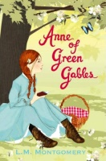
Anne of Green Gables - by L. M. Montgomery
Marilla and Matthew Cuthbert are in for a big surprise. They are waiting for an orphan boy to help with the work at Green Gables - but a skinny, red-haired girl turns up instead. Feisty and full of spirit, Anne Shirley charms her way into the Cuthberts' affection with her vivid imagination and constant chatter. It's not long before Anne finds herself in trouble, but soon it becomes impossible for the Cuthberts to imagine life without 'their' Anne - and for the people of Avonlea to recall what it was like before this wildly creative little girl whirled into town.

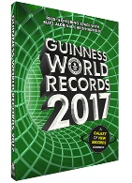
The Guinness World of Records - 2017
The world's best-selling annual is back and bursting with thousands of amazing new records, never-before-seen images, fact-packed infographics and mind-boggling trivia. And as always, we have a few more surprises in store for you…

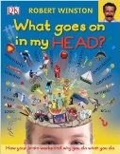
What Goes On In My Head? - by Robert Winston
Introducing you to the most powerful, complicated computer network that exists - your brain. Make sense of the brain's mind-boggling structure and understand how it controls everything you do, you'll uncover the secrets of your inner world in incredible detail.

