

**Harvest Moon**

Okay, so let’s face it- Summer is truly over now. With amber leaves littering the pavement, cold winds cutting the air and Halloween ominous and exciting, this isn’t what Astronomers (stargazers) have on their minds as Autumn means the Harvest Moon’s appearance.

So this special moon only appears one day on an Equinox. The Equinox is when the Earth’s equator (an invisible line in the middle of the planet) is almost directly pointed at the sun’s centre. However, there are two equinoxes- one in March and one in September. So surely it should’ve happened by now? It hasn’t!

For some unknown reason the Harvest Moon is coming late this year up in the Northern Hemisphere. But we do have its date; the 5th of October. The moon will supposedly be brightest around 7:40 PM. Sometimes, the moon is ORANGE!

So let’s hope it’s going to be a clear night!

By Ruby Yates

8th Edition – 3rd October 2017

By children, for children.

DILTON TIMES

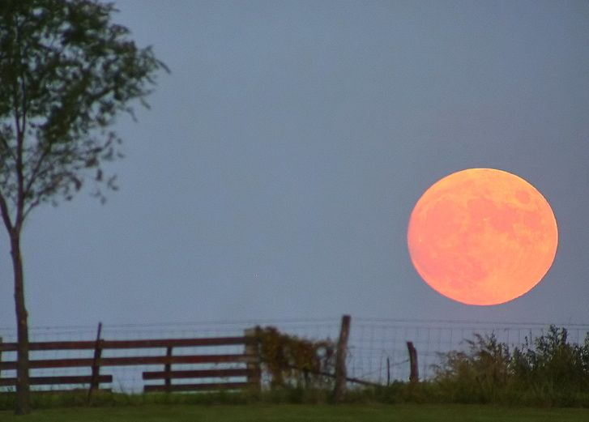

**Back to the wild**

THREE orang-utans, one male and two females were released into their natural habitat, the rainforest, by a team of conservationists. They were all being cared for at international animal rescue Orang-utan centre in Keta Pang. The monkeys were abandoned before by a man fleeing the police.

By Amelia Fairhurst

**Las Vegas attack**

It’s one of the US’s most famous cities and is very popular among tourists….but on the 30th of September some people were badly hurt and some were killed.

It happened at an open air music concert but the police confirmed the man died.

By Oscar Froggatt

**Search dog saves lives in earthquake**

Frida, a Mexican rescue dog, has been praised for saving tons of people’s lives trapped in the rubble after the country’s recent earthquake. After the 7.1 magnitude quake shook the city, Mexico’s president thanked Frida the dog for saving a lot of lives. Frida’s gear includes: protective googles, a khaki harness and two pairs of protective booties as she detects signs of life under the rubble.

By Jay Kinzett

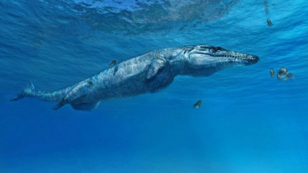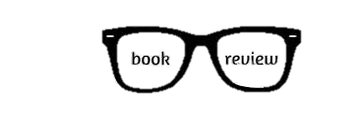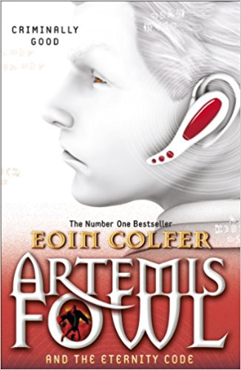

**Weird and Wonderful!**

**Crossword by Shannon and Lottie**

**What is this sea creature?**

The ancient reptile is called *Leldraan melkshamensis* or you can call it the Melksham monster. At Wilshire they found the fossil of the Melksham monster it was originally found in Melksham. The fossil has been owned by the natural history museum since 1875.

The ancient dinosaur crocodile is 10ft long and it has long sharp teeth and that allows it to feast on big fish.

By Wilf Hewitt-Grainger and Charley Oley

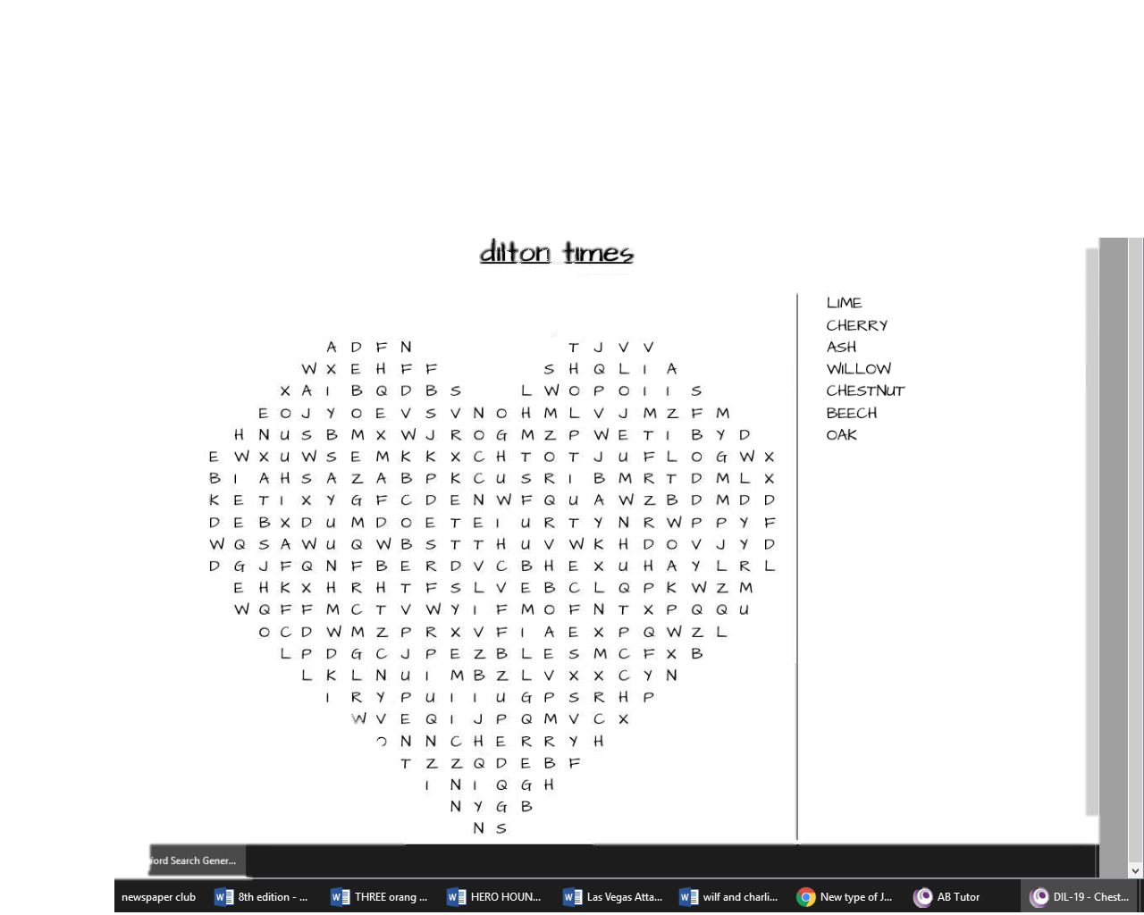

**An interview with Mr Blake**

Q: What’s your favourite colour?

A: Orange

Q: What’s your favourite food?

A: Curry

Q: What’s your favourite lesson?

A: PE

Q: What’s your favourite letter and number?

A: S and 7

Q: What’s your favourite place?

A: A rugby pitch

Q: What is your favourite book?

A: Louis Suarez

Q: What is your favourite country?

A: USA

Q: What would you be if you could change job?

A: A paramedic

By Shannon Pierce

**Artemis Fowl and the Eternity Code**

Artemis Fowl is a well-known book by many adults. It is a technology slash fictional book for ages 8-14. It is about a 14 year old boy called Artemis Fowl who teams up with his friends to stop Opal Koboi. It is a book all about mystery. Seriously, you never know what’s going to happen next! It is by Eoin Colfer and was a number one bestseller.

By Rebekah Slarke